SOUTRN REGONAL PLANNING PANEL

COUNCIL ASSESSMENT REPORT

Panel Reference | PPSSTH-172
DA Number | DA/2021/0257
LGA | Snowy Valley Council
Proposed Development | Concept development application (DA) consisting of a Spa Hotel (tourist a visitor accommodation), 80 residential lots for detached dwellings, residential flat buildings, shop top housing, multi dwelling housing (terraces) development, subdivision and associated site works at Lot 35 DP878862 Miles Franklin Drive, Talbingo.
Street Address | Miles Franklin Drive, Talbingo (Lot 35 DP 878862)
Applicant/Owner | Saile No 2 PTY LTD
Date of DA lodgement | 11/11/2021
Number of Submissions | Public Notification – 1 December 2021 to the 10 January 2022.  37 submissions objecting and 7 submissions in support of the application were received during the notification period.
Recommendation | Refusal for reasons outlined in this report.
Regional Development Criteria (Schedule 6 of State Environmental Planning Policy (Planning systems) 2021) | Capital Investment Value (CIV) exceeds $30 million for general development ($427,465,743.00)
List of all relevant s4.15(1)(a) matters | - Environmental Planning and Assessment Act 1979  - Environmental Planning and Assessment Regulation 2000  - Rural Fires Act 1997  - National Parks and Wildlife Act 1974  - Water Management Act 2000  - State Environmental Planning Policy (Planning Systems) 2021  - State Environmental Planning Policy (Transport and Infrastructure) 2021  - State Environmental Planning Policy (Resilience and Hazard) 2021  - State Environmental Planning Policy No 65 – Design Quality of Residential Apartment Development  - State Environmental Planning Policy (Koala Habitat Protection) 2021  - Tumut Local Environmental Plan 2012  - Snowy Valleys Development Control Plan 2019
List all documents submitted with this report for the Panel’s consideration | - West Talbingo Village Master Plan  - Survey Plan  - Statement of Environmental Effects  - Flora and Fauna Report  - Revised Bushfire Assessment Report  - Flood study and Engineering Report  - European and Indigenous Heritage Report  - Geotechnical Report  - Capital Investment Value Report  - Letter to Applicant October 2022  - Additional Information Submitted March/April 2023  - Snowy Valley DCP 2019 Assessment  - Recommended Reasons for Refusal
Report prepared by | Lachlan Rodgers & Jeremy Swan - The Planning Hub – Independent Town Planning Consultant on behalf of Council
Report date | 24 April 2023

Summary of s4.15 matters  Have all recommendations in relation to relevant s4.15 matters been summarized in the Executive Summary of the assessment report? | Yes
Legislative clauses requiring consent authority satisfaction  Have relevant clauses in all applicable environmental planning instruments where the consent authority must be satisfied about a particular matter been listed, and relevant recommendations summarized, in the Executive Summary of the assessment report? | Yes
Clause 4.6 Exceptions to development standards  If a written request for a contravention to a development standard (clause 4.6 of the LEP) has been received, has it been attached to the assessment report? | No
Special Infrastructure Contributions  Does the DA require Special Infrastructure Contributions conditions (S7.24)?  Note: Certain DAs in the Western Sydney Growth Areas Special Contributions Area may require specific Special Infrastructure Contributions (SIC) conditions | No
Conditions  Have draft conditions been provided to the applicant for comment?  Note: in order to reduce delays in determinations, the Panel prefer that draft conditions, notwithstanding Council’s recommendation, be provided to the applicant to enable any comments to be considered as part of the assessment report. | No

Table of Contents

1. PURPOSE OF REPORT 2
2. SUMMARY OF RECOMMENDATION 2
3. EXECUTIVE SUMMARY 2
4. BACKGROUND 6
5. THE PROPOSAL 14
6. ASSESSMENT 29
7. OTHER MATTERS 50
8. CONCLUSION 53
9. RECOMMENDATION 54

Attachments
- West Talbingo Village Master Plan
- Survey Plan
- Statement of Environmental Effects
- Flora and Fauna Report
- Revised Bushfire Assessment Report
- Flood study and Engineering Report
- European and Indigenous Heritage Report
- Geotechnical Report
- Capital Investment Value Report
- Letter to Applicant October 2022
- Additional Information Submitted April / March 2023
- Snowy Valley DCP 2019 Assessment

- Recommended Reasons for Refusal

PURPOSE OF REPORT

The purpose of this report is to seek the Southern Regional Planning Panel (the Panel) determination of a Concept Development Application (DA) consisting of a Spa Hotel (tourist a visitor accommodation), 80 residential lots for detached dwellings, residential flat buildings, shop top housing, multi dwelling housing (terraces) development, subdivision and associated site works at Lot 35 DP878862, Miles Franklin Drive, Talbingo.

The Panel is the determining authority for this DA as, pursuant to Part 2.4 of State Environmental Planning Policy (Planning System) 2021 and Schedule 4A of the Environmental Planning and Assessment Act 1979, the capital investment value (CIV) of the proposed development is $427,465,743.00 which exceeds the CIV threshold of $30 million for General Development.

SUMMARY OF RECOMMENDATION

That the Panel determine DA2021/0257 consisting of a Concept Development Application consisting of a Spa Hotel (tourist a visitor accommodation), 80 residential lots for detached dwellings, residential flat buildings, shop top housing, multi dwelling housing (terraces) development, subdivision and associated site works at Lot 35 DP878862, Miles Franklin Drive, Talbingo by way of refusal pursuant to Section 4.16 of the Environmental Planning and Assessment Act 1979.

EXECUTIVE SUMMARY

Council is in receipt of a Development Application from Saile No 2 PTY LTD submitted on 11 November 2021, seeking approval for a Concept Development Application consisting of a Spa Hotel (tourist a visitor accommodation), 80 residential lots for detached dwellings, residential flat buildings, shop top housing, multi dwelling housing (terraces) development, subdivision and associated site works at Lot 35 DP878862, Miles Franklin Drive, Talbingo.

The application seeks to create the West Talbingo Village Masterplan, incorporating a range of buildings and land uses. This includes:
- A Proposed Spa Hotel (tourist a visitor accommodation) development.
- A Mixed Use retail and residential precinct containing 11 residential flat buildings, 5 Shop top Housing Developments and 8 multi dwelling housing (terraces) development,
- Detached dwellings (80 Lots) – approximately 31,500m² GFA;
- Public Open Space (approximately 50,000m²) and through site links with associated landscaping and outdoor furniture.
- Carparking and/or service areas for boat trailers, tourist and visitor accommodation and residential properties.
- New access roads and pedestrian paths; and
- Private open space associated with residents and visitors of the Spa Hotel and Mixed use precinct.
- Concept subdivision plan showing the indicative lot configuration for lots proposed to be developed.

A briefing was held with the Panel on 2 August 2022 to discuss the proposal. The Panel noted the concerns raised by Council and its assessment planners, the significant deficiencies in the information provided in support of the application, and the concerns around the form, scale and density of the development given the village context of the site.

The Panel requested Council write to the applicants outlining the significant issues raised above and requesting the application be withdrawn. The Panel requested the Council advise the applicants that if the application is not withdrawn within 14 days, the application would be assessed and determined based on the current information before Council.

The application was lodged with an estimated cost of works of $35 million however no Quantity Surveyors Report was submitted with the application. On 25 August 2022 Council requested a formal Quantity Surveyors Report be provided to confirm the Capital Investment Value of the project.

A Capital Investment Value (CIV) Report was submitted by the applicant in October 2022 (Attachment 9) which detailed the total development cost as being $427,465,743.00. The relevant Development Application fees were calculated and paid based on the $35 million value and the applicant has refused to pay the additional application fees for the updated cost of development.

A further briefing was held on 18 October 2022 with the Panel, Council Officers and representatives of the applicant at the request of the applicant. Council outlined its concerns relating to the development including the compatibility of the proposal with the existing village and inconsistencies of the development with the zone objectives.

The Panel raised concerns regarding the suitability of the consideration of the proposal through the Concept DA assessment pathway in the absence of a comprehensive supporting strategic planning framework and given the objectives of the Village Zone. The Panel also noted the inconsistency of the proposal with the Local Strategic Planning Statement and the potential impacts of the proposal on the Talbingo Village.

Council officers undertook a review the documentation submitted with the application and issued a letter to the applicant on 25 October 2022 (Attachment 10) outlining key concerns with the proposal, detailing that the proposal was not supported and requested the applicant withdraw the application. The issues raised were as follows:

- Built Form, Scale, Density and Character
- Incompatibility with the RU5 Village Zone of the site
- significant deficiencies in the information provided in support of the application
- Public submission issues
- Incorrect planning pathway to achieve the proposal

The letter was a request for the withdrawal of the application and was not a request for additional information in accordance with the Environmental Planning and Assessment Act 1979.

A meeting was held with the applicant on 28 November 2022 to discuss Council’s letter and the way forward for the application. A further meeting was held with the applicant on 14 December 2022.

Subsequent to the meeting the applicant contacted Council on 23 December 2022 and 17 January 2023 requesting the application be held to allow for the submission of additional information within 2-3 months.

In accordance with Clause 55 of the Environmental Planning and Assessment Regulation 2000 a development application may only be amended with the agreement of the consent authority.

On 22 January 2023 Council advised the applicant that they would allow additional time until 14 February 2023 to provide additional information to support the application however noting that this did not constitute agreement that the additional information would be accepted in accordance with Clause 55 of the Environmental Planning and Assessment Regulation 2000.

On 26 January 2023 the applicant requested an extension to May 2023 to provide additional information. A further extension was provided by the Council to 23 March 2023 noting this was 3 months post the meeting in December 2022.

On 22 March 2023 the applicant requested a further extension to 26 May 2023 to provide additional information. The request for a further extension was refused by Council noting that sufficient time had been provided since the issuing of the letter on 25 October 2022. The applicant was notified that should the DA not be withdrawn it would be progressed based on the information submitted to date.

On 23 March 2023 the applicant submitted the following additional information (provided as Attachment 11):

- Statement of Environmental Effects
- Site Specific Development Control Plan
- Masterplan Concept Architectural Drawings

The applicant noted that the reports were subject to amendment resulting from the completion of further documentation. The package of information therefore did not constitute a consolidated package of information addressing all issues raised in October 2022.

On 8, 10 & 12 April 2023 the applicant submitted the following further additional information (provided as Attachment 11):

- Amended Masterplan Concept Architectural Drawings
- Contamination Assessment Fee Proposal Acceptance
- Geotechnical Investigation Fee Proposal Acceptance
- Biodiversity Assessment Fee Proposal Acceptance
- Economic Impact Assessment Fee Proposal Acceptance
- Traffic Impact Assessment Fee Proposal Acceptance
- Heritage Assessment Fee Proposal Acceptance
- Flood Study, Stormwater and Visual Impact Assessment Fee Proposal Acceptance
- Survey Plan

The package of information included a number of fee proposals which did not constitute relevant assessments or consultant reports and the applicant noted that the reports were subject to amendment resulting from the completion of further documentation. The package of information therefore did not constitute a consolidated package of information addressing all issues raised in October 2022.

It is noted that the fee proposals provided as part of the additional information were prepared and accepted in February 2023 in response to issues raised by Council in October 2022.

In accordance with Clause 55 of the Environmental Planning and Assessment Regulation 2000 Council does not accept the amended information as substantial time was allowed which was not met, an incomplete package was submitted and if the additional information was accepted it would prolong the assessment of the application requiring further referral to external agencies and extensive reporting timeframes for the panel.

The assessment has therefore been undertaken based on the documentation submitted with the original application. Notwithstanding this, if Council were to accept the additional information it is considered to be insufficient in addressing the fundamental issues raised by Council.

It is considered that a concept development application is the incorrect pathway to achieve the desired outcome for the site by the applicant. The proper process for consideration of the proposal would be a planning proposal that seeks to amend the Tumut Local Environmental Plan 2012 to provide suitable planning controls and a site-specific development control plan to facilitate future development.

An assessment of the development has been undertaken against the following Acts and environmental planning instruments:

- Environmental Planning and Assessment Act 1979
- Environmental Planning and Assessment Regulation 2000
- Rural Fires Act 1997
- National Parks and Wildlife Act 1974
- Water Management Act 2000
- State Environmental Planning Policy (Planning Systems) 2021
- State Environmental Planning Policy (Transport and Infrastructure) 2021
- State Environmental Planning Policy (Resilience and Hazard) 2021
- State Environmental Planning Policy No 65 – Design Quality of Residential Apartment Development
- State Environmental Planning Policy (Koala Habitat Protection) 2021
- Tumut Local Environmental Plan 2012
- Snowy Valleys Development Control Plan 2019

The proposed development has been assessed against the relevant matters for consideration pursuant to Section 4.15 of the Environmental Planning and Assessment Act, 1979, including likely impacts, the suitability of the site for the development, and the public interest. The proposed development is considered to be inappropriate as it will result in adverse impacts on the surrounding area, is not suitable for the site and is contrary to the public interest.

Considering the above, it is recommended that the Southern Regional Planning Panel determine the Development Application pursuant to Section 4.16(1) of the Environmental Planning and Assessment Act 1979 by way of refusal subject to the reasons provided in this report.

BACKGROUND

Application Background

The subject site is located to the south east of Miles Franklin Drive, Talbingo and directly adjoins the Talbingo Caravan Park. The site is commonly known as Miles Franklin Drive, Talbingo and is legally described as Lot 35 DP878862.

The site is zoned RU5 Rural Village under the provisions of the Tumut Local Environmental Plan 2012.

A “Residential Estate Masterplan” for Lot 35 and adjacent Lot 36 was previously lodged with Council (Kele Property Group NSW and Urban Link/Prescott Architects) in 2006. This referenced the “Talbingo Planning Study” originally carried out in 1979. It is understood that this “Estate Masterplan” was approved by Council in or about 2006 / 2007 and has subsequently lapsed and therefore is not a consideration for Council.

The Site and Locality

- Locality
The subject site is located within the village of Talbingo in the Local Government Area (LGA) of Snowy Valley Council. Talbingo is located south east of Tumut River being approximately 4km west of the Snowy Mountains Highway and 40 km south of Tumut. Talbingo is relatively small community comprising of a population of 239 people.

Talbingo is commonly known as a tourist and visitor destination being in proximity to Kosciuszko National Park, Snowy Mountains Hydro Electric Scheme, the Tumut 3 Power stations and offering a range of recreational attractions including water and winter sports, bushwalking, sight seeing and the like.

The village of Talbingo was previously owned by the Snowy Mountains Hydro Electric Authority (now Snow Hydro Ltd – SHL) until the village was passed to the Tumut Sire Council in 1994.

The built form in in the village is predominantly characterised by low density residential developments in the form of detached dwelling houses. Uses within the village are generally low scale consisting of a shopping centre, a service station, an educational establishment, recreational facilities including a country club and a number of tourist and visitor accommodation developments.

- Site
The subject site is located to the south east of Miles Franklin Drive, Talbingo and directly adjoins the Talbingo Caravan Park.

The site is commonly known as Miles Franklin Drive, Talbingo and is legally described as Lot 35 DP878862. The site is an irregular shaped allotment with a total area of 15.25 hectares. The subject site is predominantly cleared with grassed vegetation and trees scattered throughout the site. The site contains a slope towards Miles Franklin Drive.

Part of the site was previously used for temporary accommodation and workshops in conjunction with the establishment of the Snowy Mountains Scheme, buildings have been since removed leaving the site generally cleared. Remnants of former access roads and building foundations can be seen on Site Aerial.

The site’s location and context is detailed in Figures 1 and 2 below.

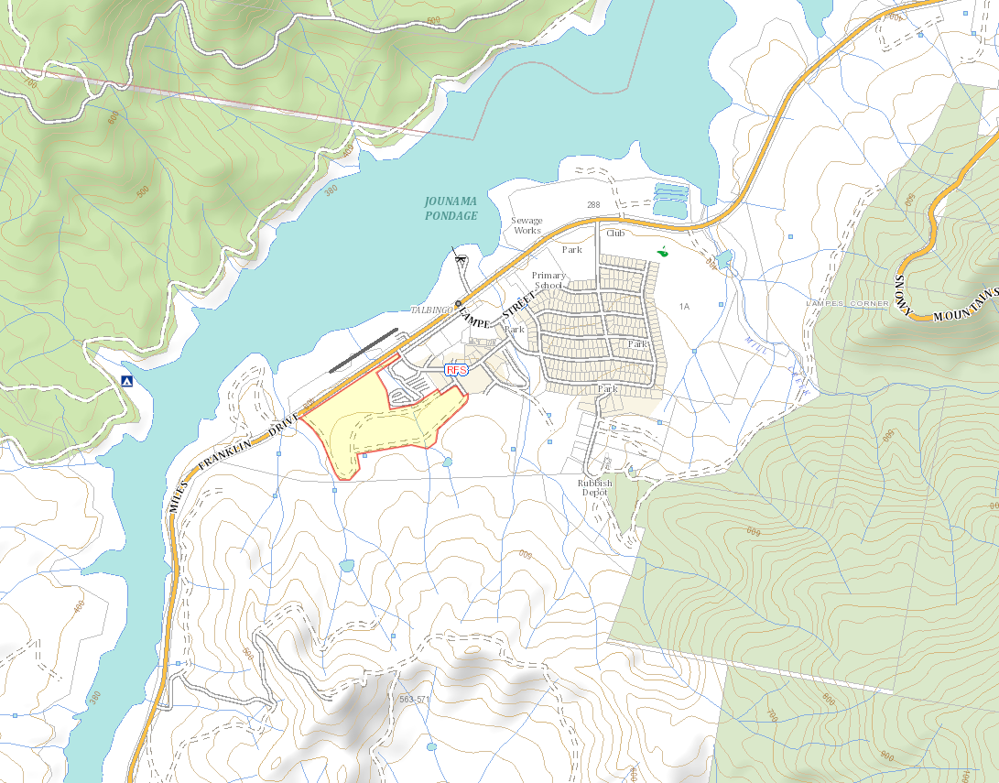
Figure 1 – Locality Plan (Source Nearmap)

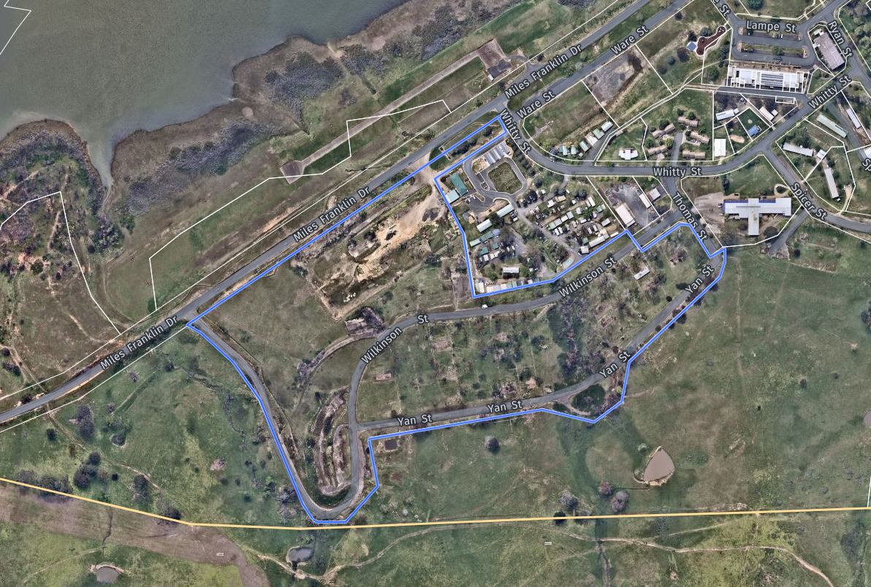
Figure 2 – Site Aerial (Source: Nearmap)

The site is zoned RU5 Village under the provisions of the Tumut Local Environmental Plan 2012. Residential accommodation, commercial premises, mixed use development, tourist and visitor accommodation and subdivision are permitted with consent.

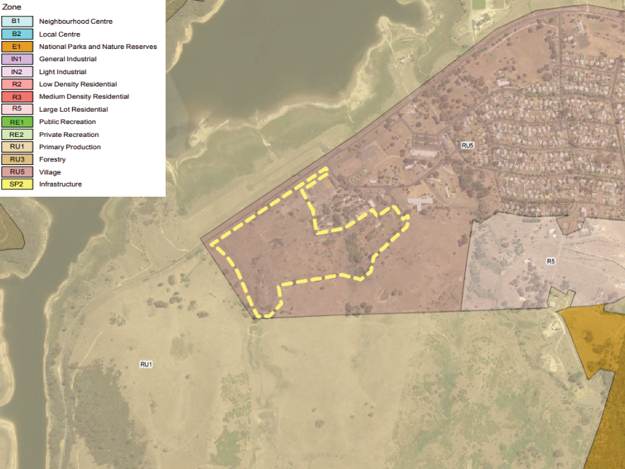
Figure 3 – Zoning Map (Source: NSW Legislation)

The Subject Application

Council is in receipt of a Development Application from Saile No 2 PTY LTD submitted on 11 November 2021, seeking approval for a Concept development application (DA) consisting of a Spa Hotel (tourist a visitor accommodation), 80 residential lots for detached dwellings, residential flat buildings, shop top housing, multi dwelling housing (terraces) development, subdivision and associated site works at Lot 35 DP878862, Miles Franklin Drive, Talbingo.

The application seeks to create the West Talbingo Village Masterplan, incorporating a range of buildings and land uses. The concept development application is to comprise the following stages:

- Stage 1 -
  - Torrens title subdivision to create 80 residential lots for the construction of dwellings houses and 1 residue lot for future stages.
  - The construction of roads and pedestrian paths servicing the residential lots.
  - Provisions of open spaces adjoining an existing watercourse.

- Stage 2 –
  - Torrens title subdivision to create 7 lots forming a mixed-use precinct and 1 residue lot.
- The construction of 11 residential flat buildings, 5 Shop top Housing Developments and 8 multi dwelling housing (terraces) development,
  - The construction of roads and pedestrian paths servicing the mixed-use precinct and future Spa hotel.
  - Provisions of public open space.

- Stage 3 –
  - Construction of a Spa Hotel (Tourist and visitor accommodation) and associated works.

Note - No physical works are proposed under this application. Future development applications for each stage are to be lodged following Concept DA approval.

These are shown on the following precinct/Master Plan map.

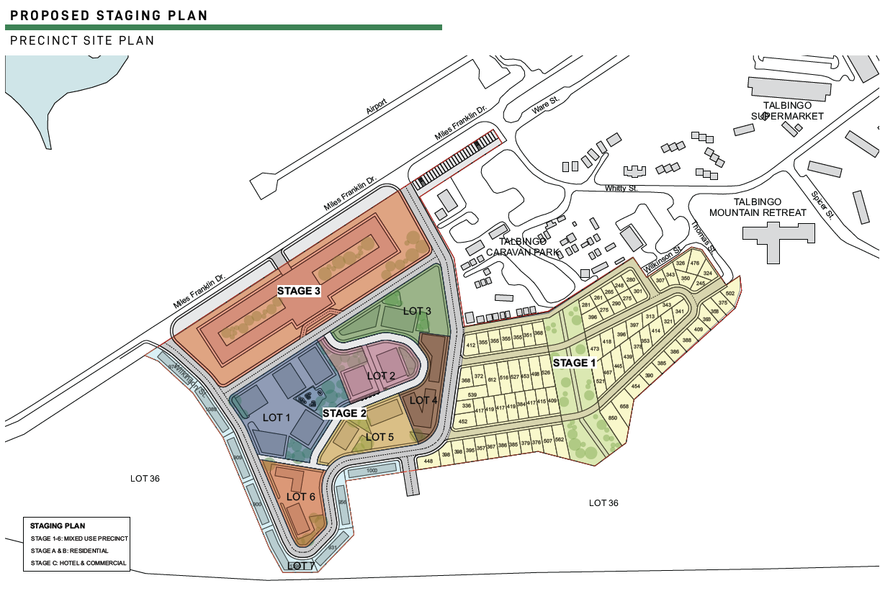
Figure 4: Staged Precinct Masterplan (Source: West Talbingo Village Masterplan – Robert Harwood Architects)

Notification and Referrals

The subject application is classed as Integrated Development under Clause 4.46 of the Environmental Planning and Assessment Act 1979 (EP&A Act) as follows:

- Natural Resource Access Regulator (NRAR) - A controlled activity at a specified location in, on or under waterfront land (within 40m) (Water Management Act 2000).
- Rural Fire Service (RFS) - Subdivision of Bushfire Prone land for residential purposes (Rural Fires Act 1997)
- NSW Office of Environment & Heritage - The land may contain items which are of archaeological or heritage significance (National Parks & Wildlife Act 1974).

On 20 May 2022 NSW RFS requested additional information noting that the Bushfire Report submitted in support of the application was prepared in 2006. An updated Bushfire Report was requested to be provided within 100 days.

On 12 September 2022 NSW RFS advised they cannot support the proposed development as the requested information was not received within the legislative timeframe to allow for assessment of the application.

Due to Council’s issues with the application and the deficiencies with the documentation submitted in support of the application the DA was not referred to NRAR or the NSW Office of Environment & Heritage. The applicant did not provide additional information within the timeframe provided by Council and therefore no referrals were made to the relevant agencies.

The Development Application was advertised for a period of 28 days between 01 December 2021 and 10 January 2022. 44 submissions were received of which 7 were in support and 37 objected to the application during that notification period.

Application History

A briefing was held with the Panel on 2 August 2022 to discuss the proposal. The Panel noted the concerns raised by Council and its assessment planners, the significant deficiencies in the information provided in support of the application, and the concerns around the form, scale and density of the development given the village context of the site.

The Panel requested Council write to the applicants outlining the significant issues raised above and requesting the application be withdrawn. The Panel requested the Council advise the applicants that if the application is not withdrawn within 14 days, the application would be assessed and determined based on the current information before Council.

The application was lodged with an estimated cost of works of $35 million however no Quantity Surveyors Report was submitted with the application. On 25 August 2022 Council requested a formal Quantity Surveyors Report be provided to confirm the Capital Investment Value of the project.

A Capital Investment Value (CIV) Report was submitted by the applicant in October 2022 (Attachment 9) which detailed the total development cost as being $427,465,743.00. The relevant Development Application fees were calculated and paid based on the $35 million value and the applicant has refused to pay the additional application fees for the updated cost of development.

A further briefing was held on 18 October 2022 with the Panel, Council Officers and representatives of the applicant at the request of the applicant. Council outlined its concerns relating to the development including the compatibility of the proposal with the existing village and inconsistencies of the development with the zone objectives.

The Panel raised concerns regarding the suitability of the consideration of the proposal through the Concept DA assessment pathway in the absence of a comprehensive supporting strategic planning framework and given the objectives of the Village Zone. The Panel also noted the inconsistency of the proposal with the Local Strategic Planning Statement and the potential impacts of the proposal on the Talbingo Village.

Council officers undertook a review the documentation submitted with the application and issued a letter to the applicant on 25 October 2022 (Attachment 10) outlining key concerns with the proposal, detailing that the proposal was not supported and requested the applicant withdraw the application. The issues raised were as follows:

- Built Form, Scale, Density and Character
- Incompatibility with the RU5 Village Zone of the site
- significant deficiencies in the information provided in support of the application
- Public submission issues
- Incorrect planning pathway to achieve the proposal

The letter was a request for the withdrawal of the application and was not a request for additional information in accordance with the Environmental Planning and Assessment Act 1979.

A meeting was held with the applicant on 28 November 2022 to discuss Council’s letter and the way forward for the application. A further meeting was held with the applicant on 14 December 2022.

Subsequent to the meeting the applicant contacted Council on 23 December 2022 and 17 January 2023 requesting the application be held to allow for the submission of additional information within 2-3 months.

In accordance with Clause 55 of the Environmental Planning and Assessment Regulation 2000 a development application may only be amended with the agreement of the consent authority.

On 22 January 2023 Council advised the applicant that they would allow additional time until 14 February 2023 to provide additional information to support the application however noting that this did not constitute agreement that the additional information would be accepted in accordance with Clause 55 of the Environmental Planning and Assessment Regulation 2000.

On 26 January 2023 the applicant requested an extension to May 2023 to provide additional information. A further extension was provided by the Council to 23 March 2023 noting this was 3 months post the meeting in December 2022.

On 22 March 2023 the applicant requested a further extension to 26 May 2023 to provide additional information. The request for a further extension was refused by Council noting that sufficient time had been provided since the issuing of the letter on 25 October 2022. The applicant was notified that should the DA not be withdrawn it would be progressed based on the information submitted to date.

On 23 March 2023 the applicant submitted the following additional information (provided as Attachment 11):

- Statement of Environmental Effects
- Site Specific Development Control Plan
- Masterplan Concept Architectural Drawings

The applicant noted that the reports were subject to amendment resulting from the completion of further documentation and that the following requested information was yet to be completed:

  - ADG Assessment, Landscape Concept, Public Domain Plan
  - Preliminary Site Contamination Study
  - Stormwater Management Concept Strategy + Flood Data
  - Site Services
  - Traffic Management
  - Heritage and Archaeological Report
  - Site Survey
  - Views/Visual Impact Assessment
  - Economic Impact Assessment

The package of information therefore did not constitute a consolidated package of information addressing all issues raised in October 2022.

On 8, 10 & 12 April 2023 the applicant submitted the following further additional information (provided as Attachment 11):

- Amended Masterplan Concept Architectural Drawings
- Contamination Assessment Fee Proposal Acceptance
- Geotechnical Investigation Fee Proposal Acceptance
- Biodiversity Assessment Fee Proposal Acceptance
- Economic Impact Assessment Fee Proposal Acceptance
- Traffic Impact Assessment Fee Proposal Acceptance
- Heritage Assessment Fee Proposal Acceptance
- Flood Study, Stormwater and Visual Impact Assessment Fee Proposal Acceptance
- Survey Plan

The package of information included a number of fee proposals which did not constitute relevant assessments or consultant reports and the applicant noted that the reports were subject to amendment resulting from the completion of further documentation. The package of information therefore did not constitute a consolidated package of information addressing all issues raised in October 2022.

It is noted that the fee proposals provided as part of the additional information were prepared and accepted in February 2023 in response to issues raised by Council in October 2022.

In accordance with Clause 55 of the Environmental Planning and Assessment Regulation 2000 Council does not accept the amended information as substantial time was allowed which was not met, an incomplete package was submitted and if the additional information was accepted it would prolong the assessment of the application requiring further referral to external agencies and extensive reporting timeframes for the panel.

The assessment has therefore been undertaken based on the documentation submitted with the original application. Notwithstanding this, if Council were to accept the additional information it is considered to be insufficient in addressing the fundamental issues raised by Council.

THE PROPOSAL

The proposal seeks Concept development application (DA) consisting of a Spa Hotel (tourist a visitor accommodation), 80 residential lots for detached dwellings, residential flat buildings, shop top housing, multi dwelling housing (terraces) development, subdivision and associated site works at Lot 35 DP878862, Miles Franklin Drive, Talbingo. Specifically, the concept approval includes the following:

- A Proposed Spa Hotel (tourist a visitor accommodation) development.
- A Mixed-Use retail and residential precinct containing 11 residential flat buildings, 5 Shop top Housing Developments and 8 multi dwelling housing (terraces) development.
- Detached dwellings (80 Lots) – approximately 31,500m² GFA;
- Public Open Space (approximately 50,000m²) and through site links with associated landscaping and outdoor furniture.
- Carparking and/or service areas for boat trailers, tourist and visitor accommodation and residential properties.
- New access roads and pedestrian paths; and
- Private open space associated with residents and visitors of the Spa Hotel and Mixed use precinct.
- Concept subdivision plan showing the indicative lot configuration for lots proposed to be developed.

Proposed Staging

The concept approval is proposed to be staged as follows:

- Stage 1 -
  - Torrens title subdivision to create 80 residential lots for the construction of dwellings houses and 1 residue lot for future stages.
  - The construction of roads and pedestrian paths servicing the residential lots.
  - Provisions of open spaces adjoining an existing watercourse.

- Stage 2 –
  - Torrens title subdivision to create 7 lots forming a mixed-use precinct and 1 residue lot.
- The construction of residential flat buildings, Shop top Housing and multi dwelling housing (terraces),
  - The construction of roads and pedestrian paths servicing the mixed-use precinct and future Spa hotel.
  - Provisions of open spaces.

- Stage 3 –
  - Construction of a Spa Hotel (Tourist and visitor accommodation) and associated works.

Note - No physical works are proposed under this application. Future development applications for each stage are to be lodged following Concept DA approval.

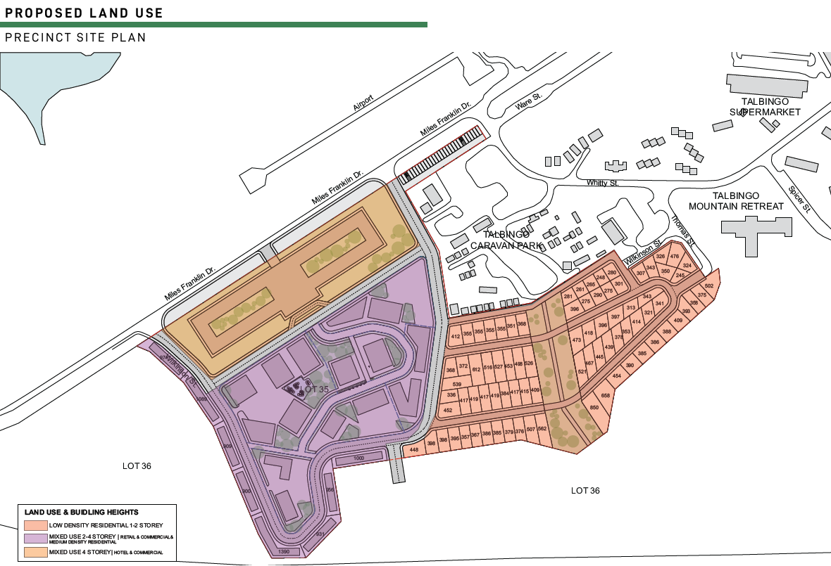
Figure 5: Site Plan (Source: Robert Harwood Architects)
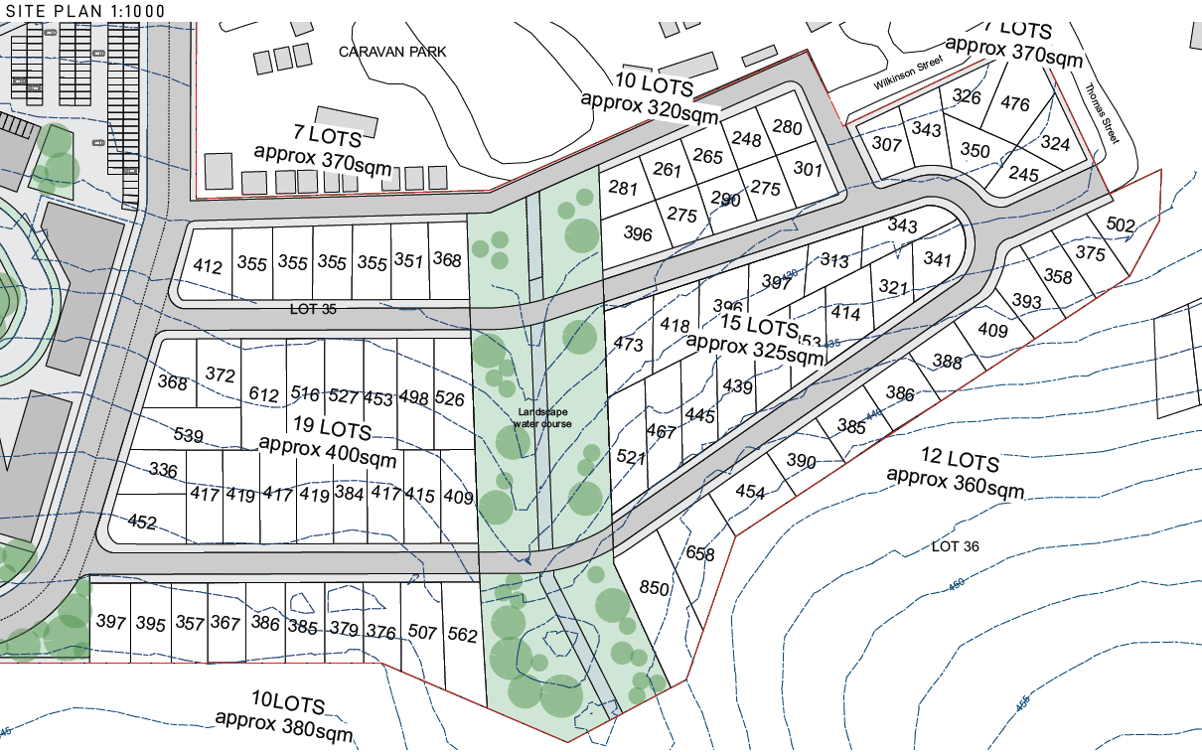
Figure 6: Low Density Residential Site Plan (Source: Robert Harwood Architects)
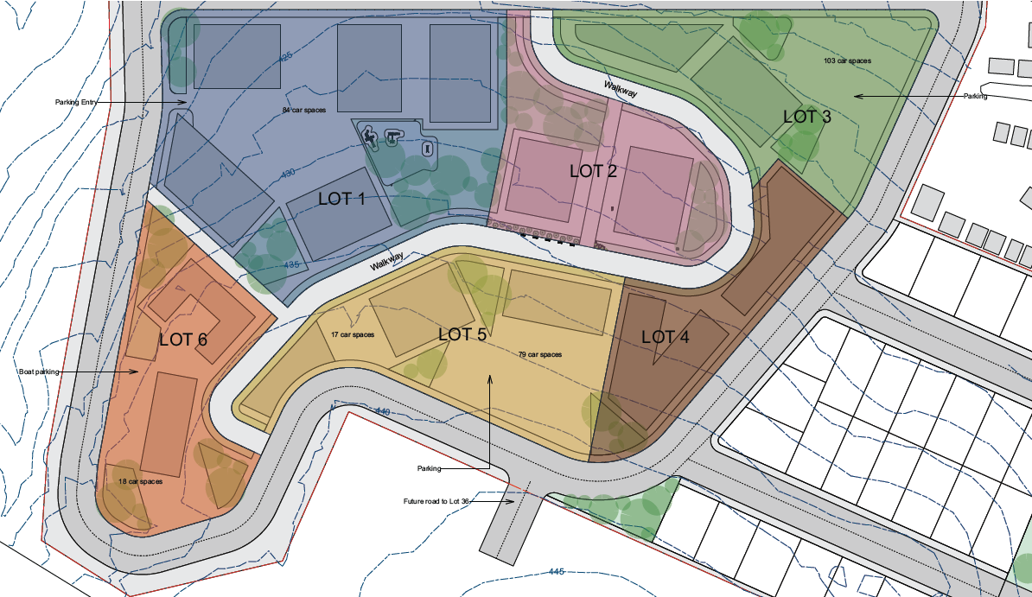
Figure 7: Mixed–Use Precinct Site Plan (Source: Robert Harwood Architects)

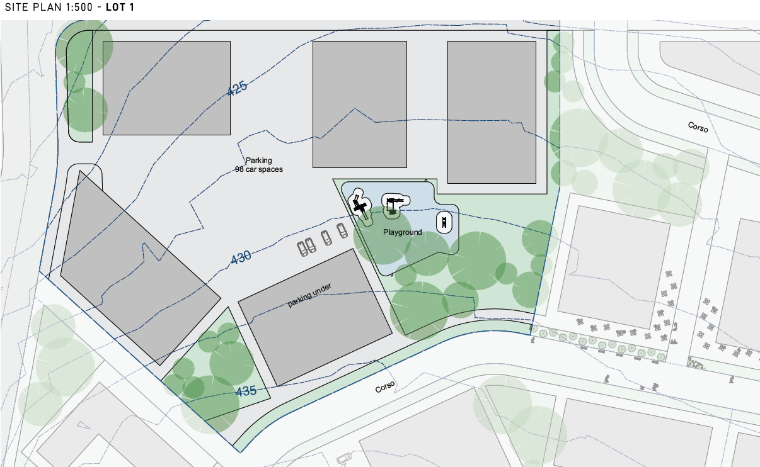
Figure 8 – Lot 1 of the Mixed–Use Precincts Site Plan (Source: Robert Harwood Architects))
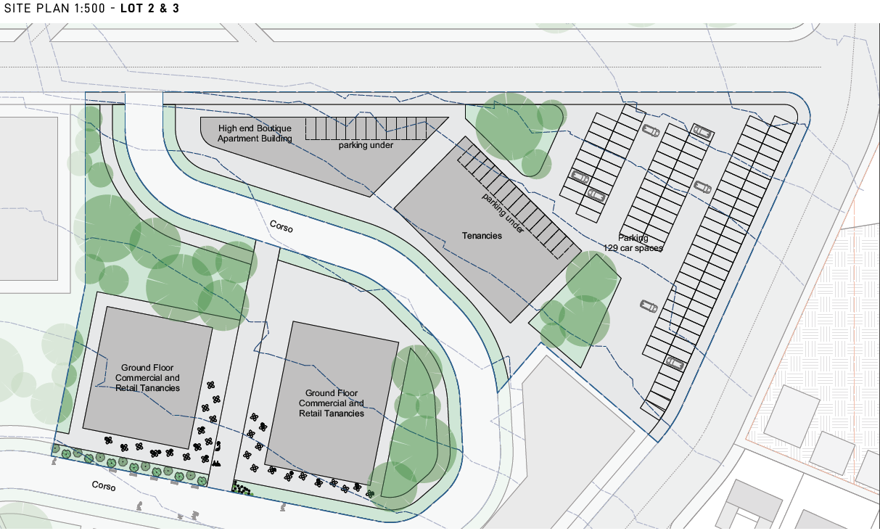
Figure 9 – Lot 2 and 3 of the Mixed–Use Precincts Site Plan (Source: Robert Harwood Architects)

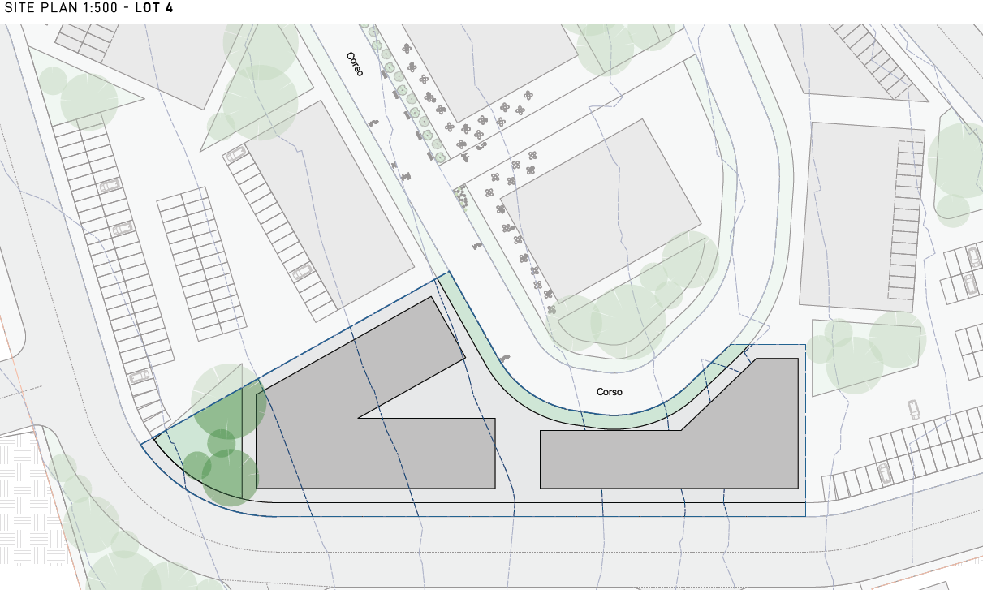
Figure 10 – Lot 4 of the Mixed–Use Precincts Site Plan (Source: Robert Harwood Architects)

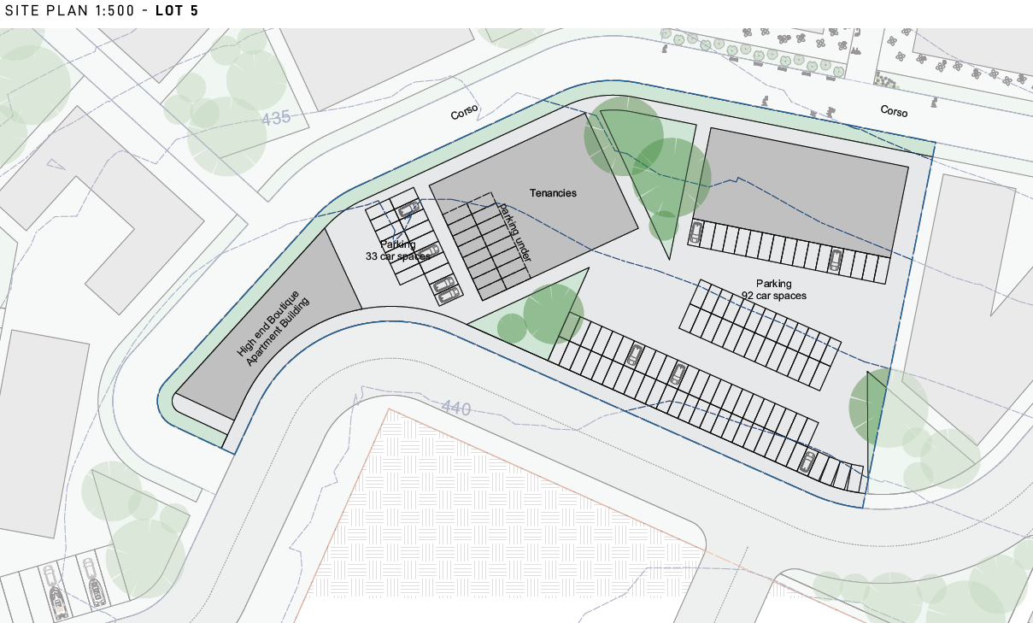
Figure 11 – Lot 5 of the Mixed–Use Precincts Site Plan (Source: Robert Harwood Architects)

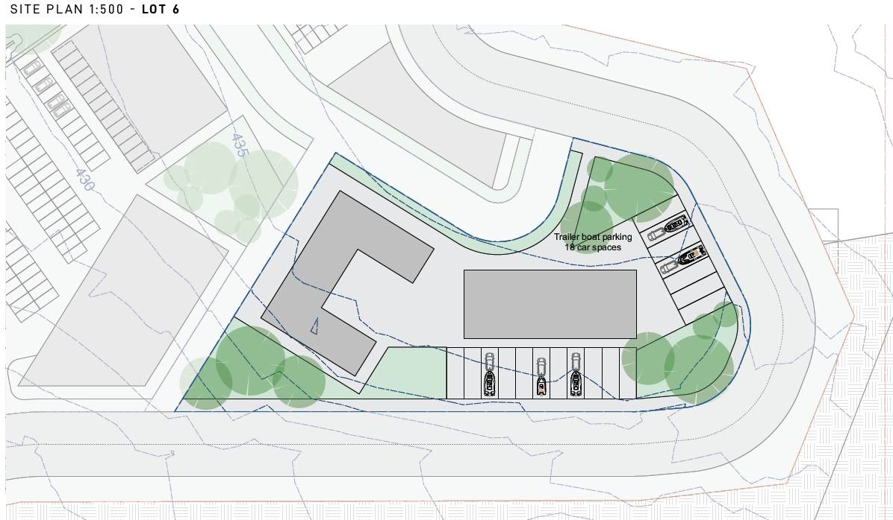
Figure 12 – Lot 6 of the Mixed–Use Precincts Site Plan (Source: Robert Harwood Architects)

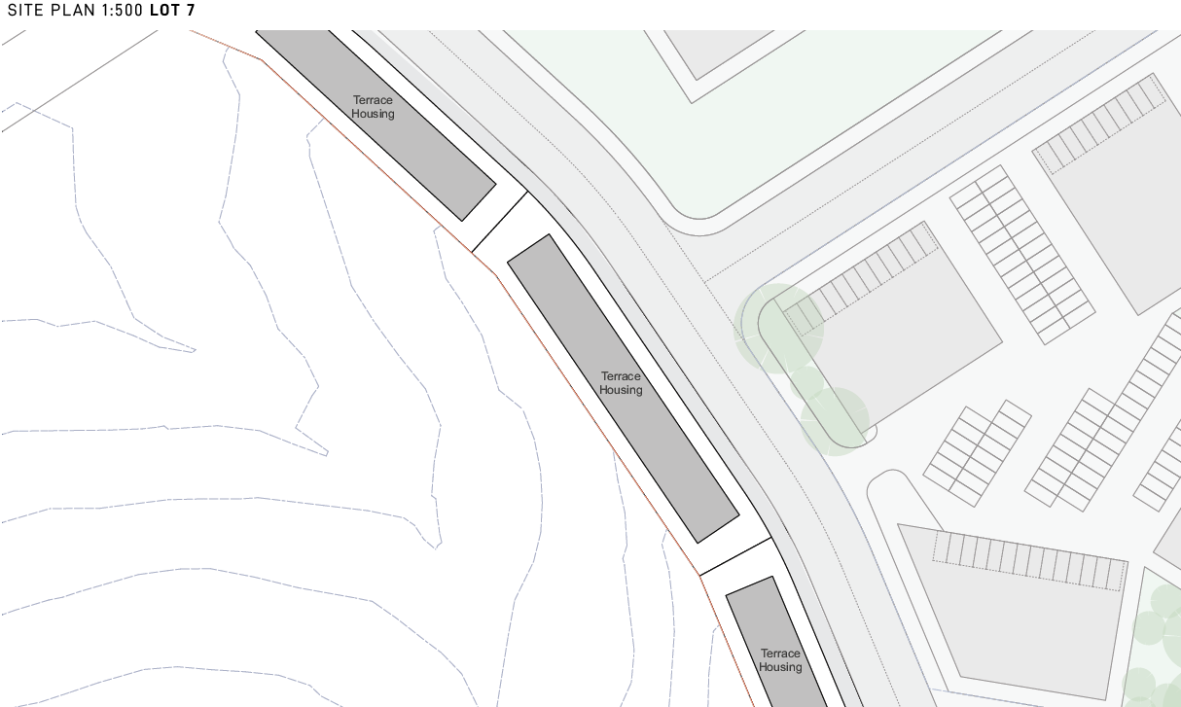
Figure 13 – Part of Lot 7 of the Mixed–Use Precincts Site Plan (Source: Robert Harwood Architects)

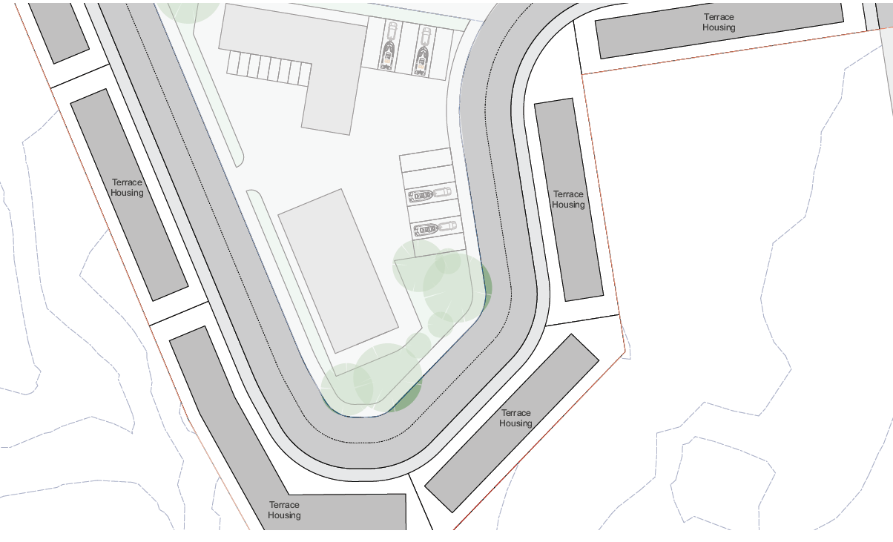
Figure 14 – Part of Lot 7 of the Mixed–Use Precincts Site Plan (Source: Robert Harwood Architects)

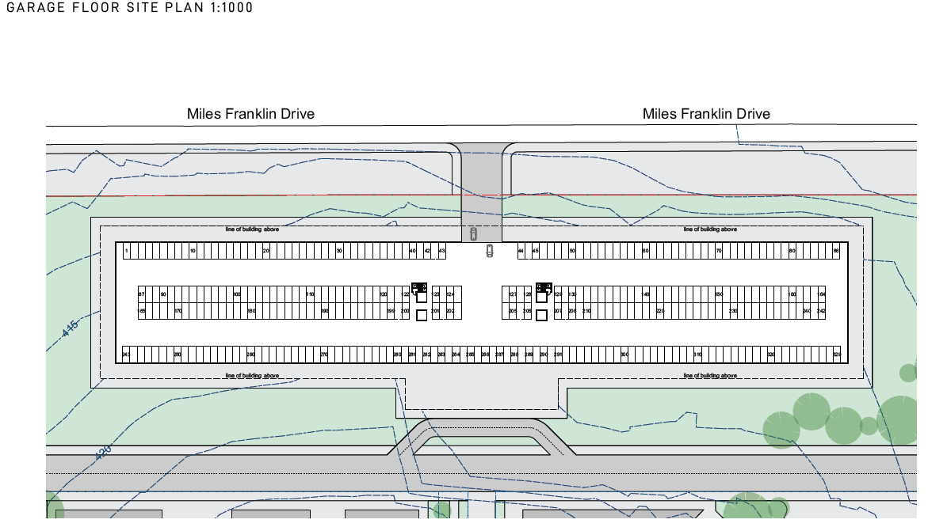
Figure 15 – Spa Hotel Garage Floor Site Plan Site Plan (Source: Robert Harwood Architects)

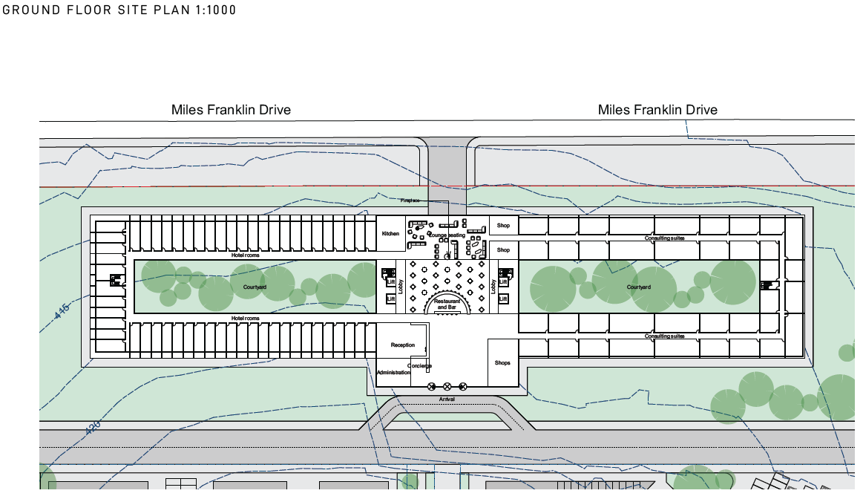
Figure 16 – Spa Hotel Ground Floor Site Plan Site Plan (Source: Robert Harwood Architects)
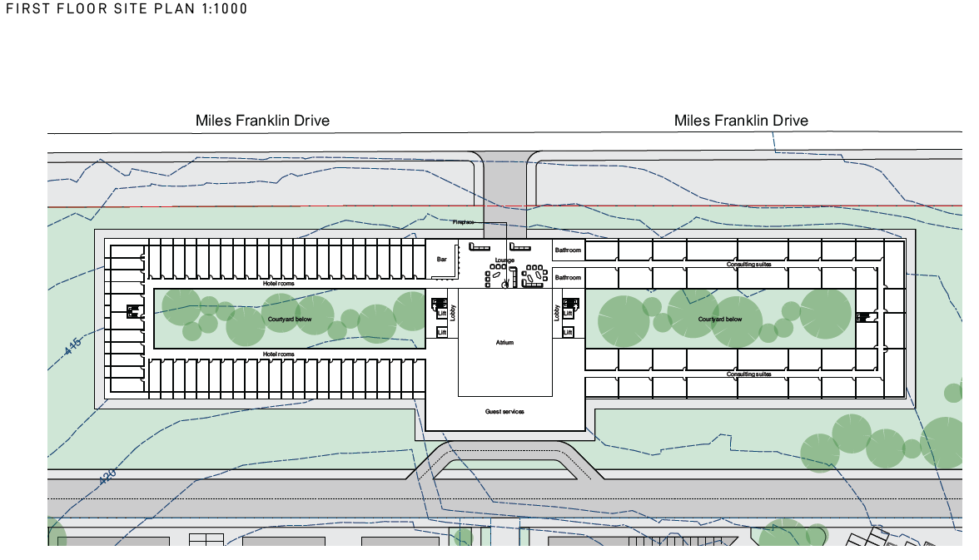
Figure 17 – Spa Hotel First Floor Site Plan Site Plan (Source: Robert Harwood Architects)

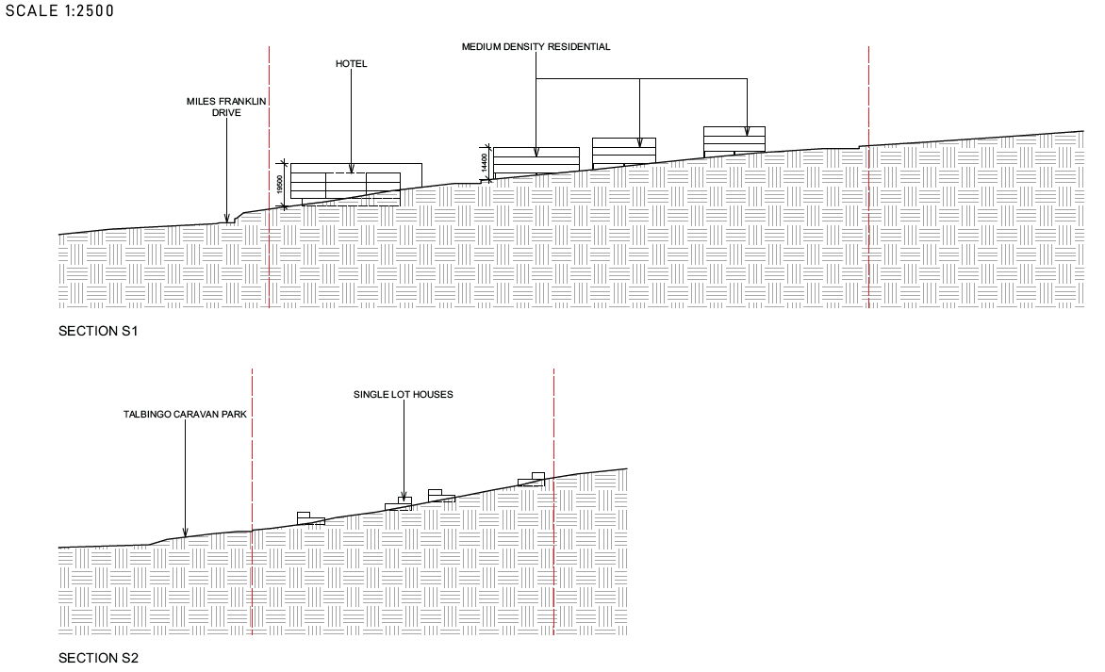
Figure 18 – Site Sections (Source: Robert Harwood Architects)

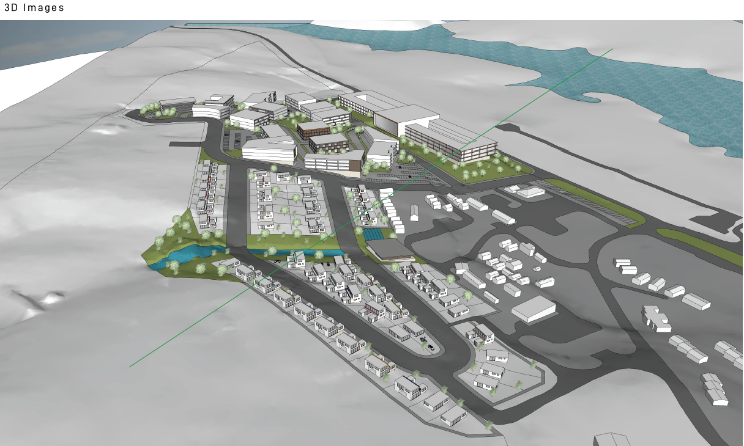
Figure 19: Concept Vision (Source: Robert Harwood Architects)

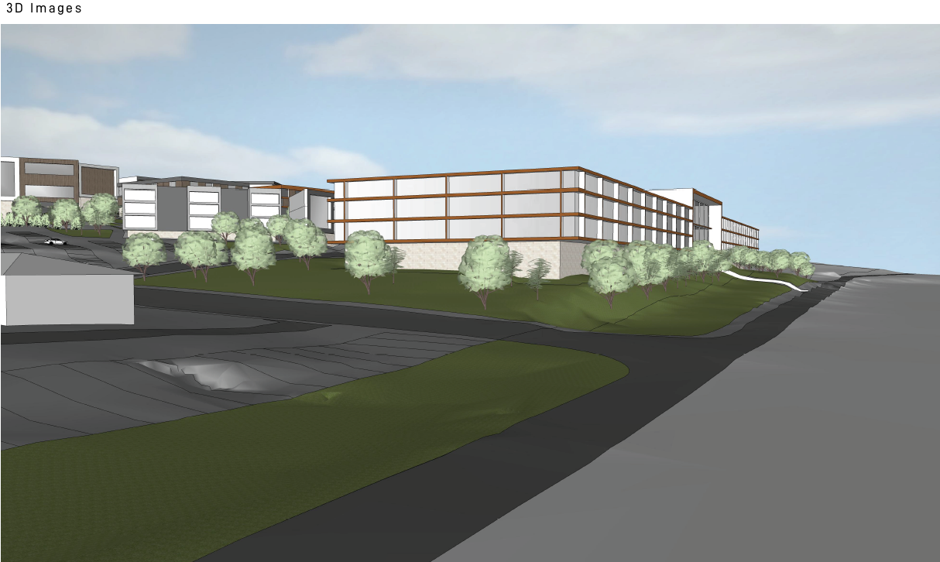
Figure 20: Concept Vision (Source: Robert Harwood Architects)

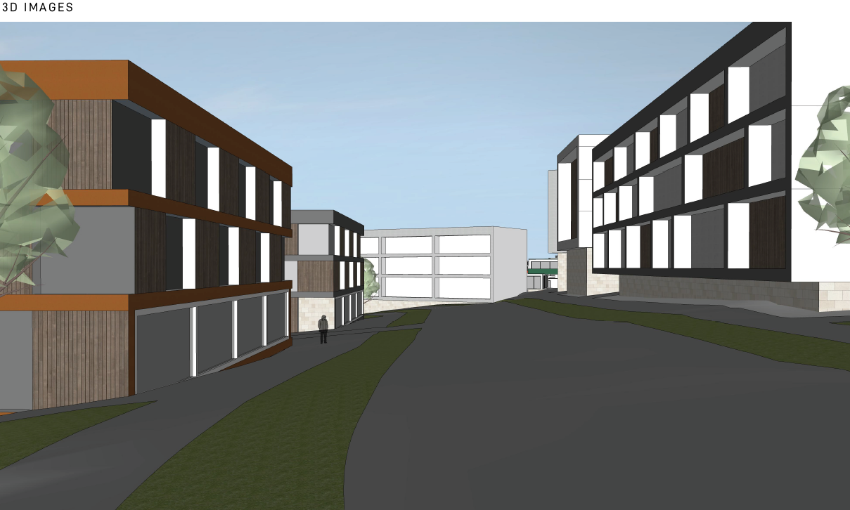
Figure 21: Concept Vision (Source: Robert Harwood Architects)

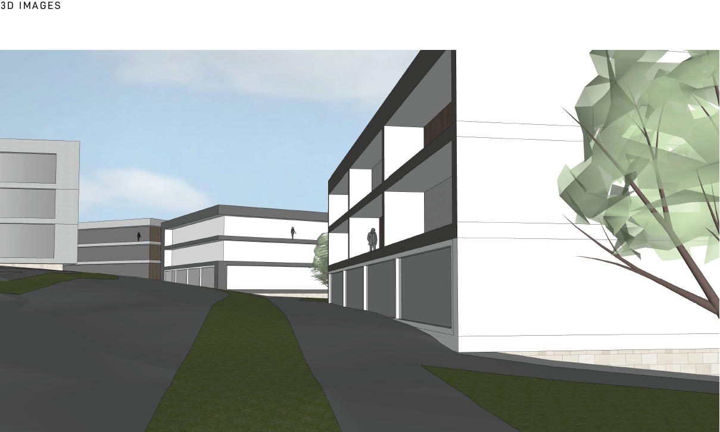
Figure 22: Concept Vision (Source: Robert Harwood Architects)

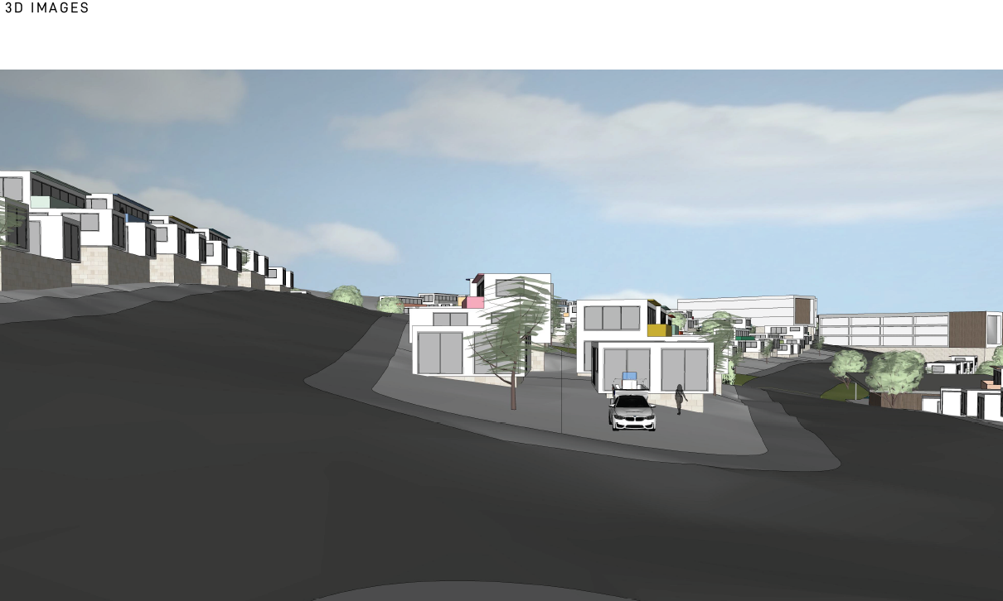
Figure 23: Concept Vision (Source: Robert Harwood Architects)

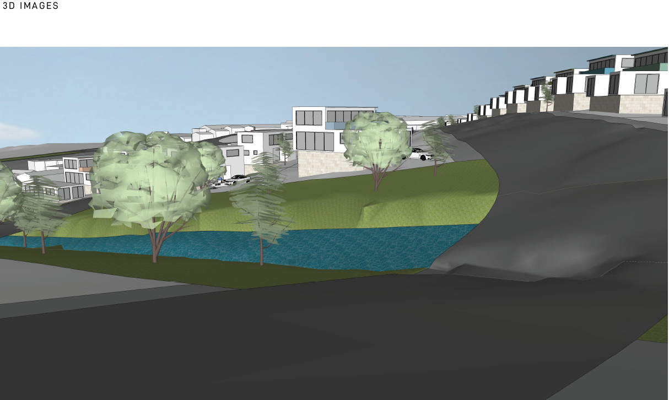
Figure 24: Concept Vision (Source: Robert Harwood Architects)

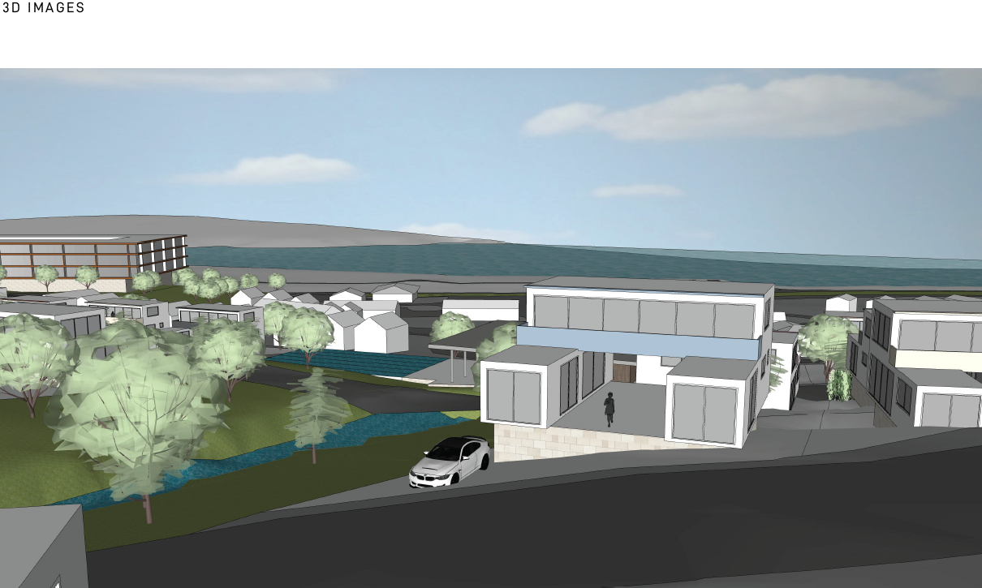
Figure 25: Concept Vision (Source: Robert Harwood Architects)

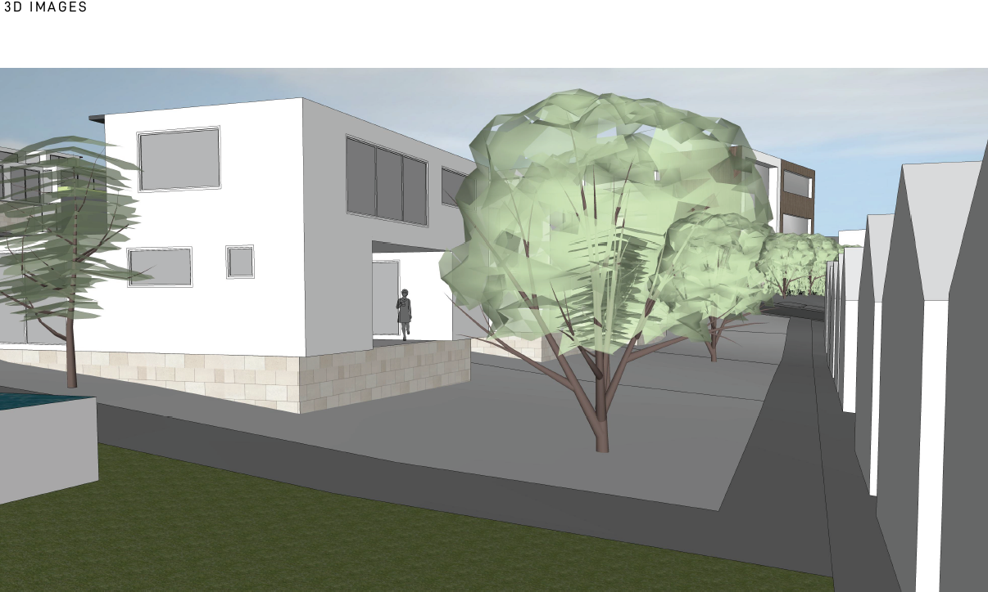
Figure 26: Concept Vision (Source: Robert Harwood Architects)

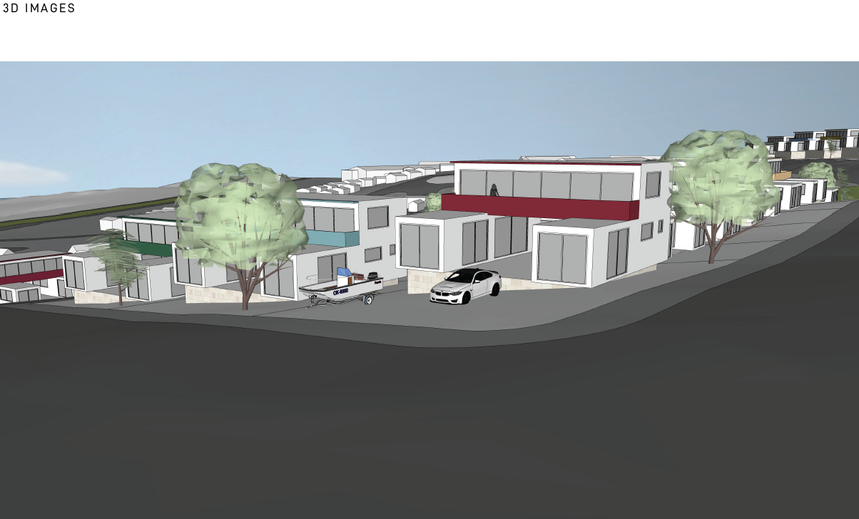
Figure 27: Concept Vision (Source: Robert Harwood Architects)

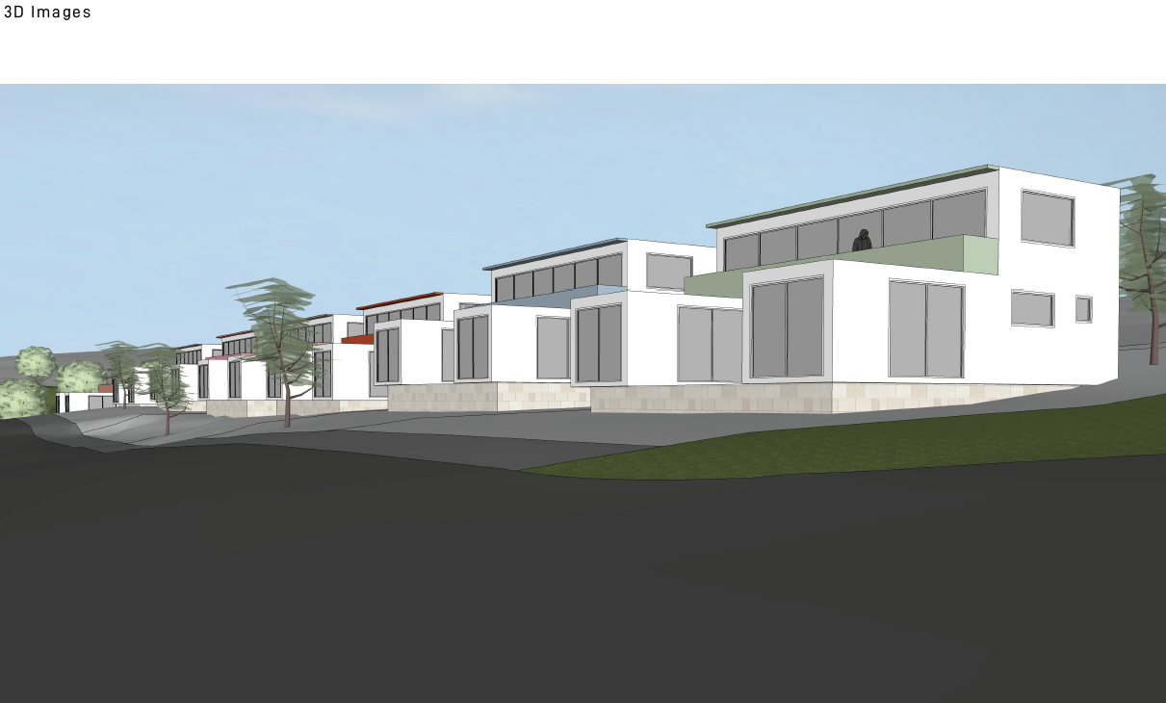
Figure 28: Concept Vision (Source: Robert Harwood Architects)

Masterplan Timeline

The proposed West Talbingo Masterplan is proposed to be staged. The applicant specifically provides an indicative timeframe for the completion of each stage. This includes:

- Stage 1 involving Torrens title subdivision to create 80 residential lots and 1 residue lot, construction of dwellings houses and the provisions of roads, pedestrian paths, public open space and essential services is envisaged to be completed over 5 years.

- Stage 2 involving the Torrens title subdivision of a residue lot to create 7 mixed-use retail and residential lots and 1 residue lot. The mixed use precinct is proposed to comprise of commercial uses, multi-dwelling housing (terrace) developments, apartment buildings and the provisions of roads, pedestrian paths, public open space and essential services to be completed over 10 years.

- Stage 3 involving the construction of a Spa Hotel (tourist and visitor accommodation) is envisaged to be completed within 15 years.

Access and Carparking

The precinct is proposed to be serviced by new roads and pedestrian paths to be constructed in association with the relevant stages.

The low-density residential development proposed under stage 1 is intended to be serviced by new local roads and pedestrian paths providing connection to Wilkinson Street and Thomas Street to the west and connecting to a future access road to the east.

The proposed mixed-use precinct under stage 2 is proposed to be serviced by a new access road providing a connection to Miles Franklin Drive. Additionally, the provision of new through-site links is proposed within the mixed-use precinct.

The Spa Hotel (Stage 3) is proposed to be serviced by a new local access road providing two separate connections to roads proposed under stage 2. Furthermore, access is proposed to Miles Franklin Drive.

The proposed vehicle and pedestrian access are shown in Figure 29 and 30 below.

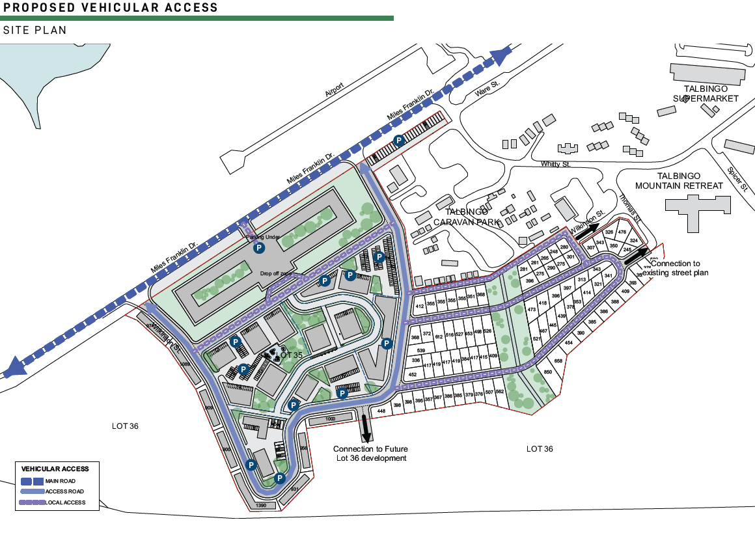
Figure 29: Vehicular Access (Source: Robert Harwood Architects)

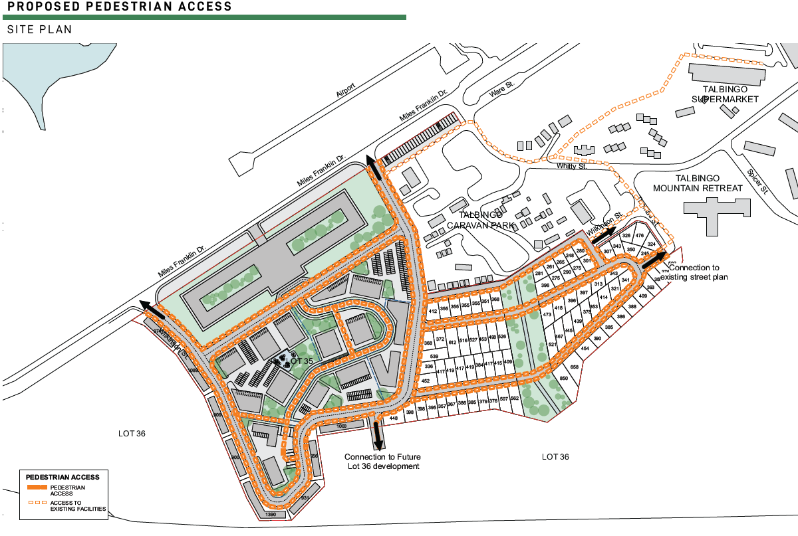
Figure 30: Pedestrian Access (Source: Robert Harwood Architects)

ASSESSMENT

An assessment against 4.15 of the Environmental Planning and Assessment Act 1979 is provided below.

Environmental Planning and Assessment Act 1979 – Section 4.15

In determining a DA, the consent authority is to take into consideration the following matter as are of relevance in the assessment of the DA on the subject property.

(a)(i) The Provisions of any Environmental Planning Instrument

The Environmental Planning Instruments that relate to the proposed development are:

- Environmental Planning and Assessment Act 1979
- Environmental Planning and Assessment Regulation 2000
- Rural Fires Act 1997
- National Parks and Wildlife Act 1974
- Water Management Act 2000
- State Environmental Planning Policy (Planning Systems) 2021
- State Environmental Planning Policy (Transport and Infrastructure) 2021
- State Environmental Planning Policy (Resilience and Hazard) 2021
- State Environmental Planning Policy No 65 – Design Quality of Residential Apartment Development
- State Environmental Planning Policy (Koala Habitat Protection) 2021
- Tumut Local Environmental Plan 2012
- Snowy Valleys Development Control Plan 2019

An assessment of the proposed DA against the above instruments is detailed below.

Environmental Planning and Assessment Act 1979 (EP&A Act)

Section 4.22 of the EP&A Act states the following in relation to concept development applications:

- For the purposes of this Act, a concept development application is a development application that sets out concept proposals for the development of a site, and for which detailed proposals for the site or for separate parts of the site are to be the subject of a subsequent development application or applications.

- In the case of a staged development, the application may set out detailed proposals for the first stage of development.

- A development application is not to be treated as a concept development application unless the applicant requests it to be treated as a concept development application.

- If consent is granted on the determination of a concept development application, the consent does not authorise the carrying out of development on any part of the site concerned unless—

  - consent is subsequently granted to carry out development on that part of the site following a further development application in respect of that part of the site, or

  - the concept development application also provided the requisite details of the development on that part of the site and consent is granted for that first stage of development without the need for further consent.

The terms of a consent granted on the determination of a concept development application are to reflect the operation of this subsection.

- The consent authority, when considering under section 4.15 the likely impact of the development the subject of a concept development application, need only consider the likely impact of the concept proposals (and any first stage of development included in the application) and does not need to consider the likely impact of the carrying out of development that may be the subject of subsequent development applications.

It is noted that the applicant has requested the subject application be assessed as a concept development application and no physical works are proposed. This assessment has therefore been undertaken in accordance with Section 4.22 of the EP&A Act.

Section 4.46 of the EP&A Act defines integrated development as development that requires development consent and one or more approvals under other State Government Acts. The subject application is classed as Integrated Development under Clause 4.46 of the Environmental Planning and Assessment Act 1979 (EP&A Act) as follows:

- Natural Resource Access Regulator (NRAR) - A controlled activity at a specified location in, on or under waterfront land (within 40m) (Water Management Act 2000).
- Rural Fire Service (RFS) - Subdivision of Bushfire Prone land for residential purposes (Rural Fires Act 1997)
- NSW Office of Environment & Heritage - The land may contain items which are of archaeological or heritage significance (National Parks & Wildlife Act 1974).

On 20 May 2022 NSW RFS requested additional information noting that the Bushfire Report submitted in support of the application was prepared in 2006. An updated Bushfire Report was requested to be provided within 100 days.

On 12 September 2022 NSW RFS advised they cannot support the proposed development as the requested information was not received within the legislative timeframe to allow for assessment of the application.

Due to Council’s issues with the application and the deficiencies with the documentation submitted in support of the application the DA was not referred to NRAR or the NSW Office of Environment & Heritage. The applicant did not provide additional information within the timeframe provided by Council and therefore no referrals were made to the relevant agencies.

Environmental Planning and Assessment (EP&A) Regulation 2000

Insufficient information was submitted with the application to satisfy the information and document requirements for a development application as required by Schedule 1 of the Environmental Planning and Assessment (EP&A) Regulation 2000. The deficiencies in the documentation are set out throughout this report.

Rural Fires Act 1997

In accordance with Section 100B of the Rural Fires Act 1997, an application to subdivide bush fire prone land that could be used for residential or rural residential purposes is to be made to the NSW RFS. The subject site is mapped as being bushfire prone.

On 20 May 2022 NSW RFS requested additional information noting that the Bushfire Report submitted in support of the application was prepared in 2006. An updated Bushfire Report was requested to be provided within 100 days.

On 12 September 2022 NSW RFS advised they cannot support the proposed development as the requested information was not received within the legislative timeframe to allow for assessment of the application.

National Parks and Wildlife Act 1974

In accordance with Section 90 of the National Parks and Wildlife Act 1974, an application for a aboriginal heritage Impact permit is to be made to the NSW Office of Environment & Heritage. The site may contain items that are of archaeological or heritage significance.

Due to Council’s issues with the application and the deficiencies with the documentation submitted in support of the application the DA was not referred to NSW Office of Environment & Heritage. The applicant did not provide additional information within the timeframe provided by Council and therefore no referral was made.

Water Management Act 2000

In accordance with Section 91 of the Water Management Act 2000, an application for controlled activity approval at a specified location in, on or under waterfront Land (within 40m) is to be made to NRAR. The site contains natural drainage lines.

Due to Council’s issues with the application and the deficiencies with the documentation submitted in support of the application the DA was not referred to NRAR. The applicant did not provide additional information within the timeframe provided by Council and therefore no referral was made.

State Environmental Planning Policy (Planning Systems) 2021

In accordance with Schedule 7 Regionally Significant Development of the SEPP, the proposed development constitutes ‘Regional Development’ as it has a Capital Investment Value (CIV) of over $30 million threshold for general development. Determination of the Application will therefore be made by the Southern Regional Planning Panel.

The application was lodged with an estimated cost of works of $35 million however no Quantity Surveyors Report was submitted with the application. On 25 August 2022 Council requested a formal Quantity Surveyors Report be provided to confirm the Capital Investment Value of the project.

A Capital Investment Value (CIV) Report was submitted by the applicant in October 2022 (Attachment 9) which detailed the total development cost as being $427,465,743.00.

State Environmental Planning Policy (Transport and Infrastructure) 2021

The proposed development could be considered to be traffic generating development in accordance with Schedule 3 of State Environmental Planning Policy (Transport and Infrastructure) 2021 as it would facilitate the future development of the site for over 300 dwellings however insufficient information was submitted in support of the application to allow for a referral to Transport for NSW.

State Environmental Planning Policy (Resilience and Hazard) 2021

Chapter 4 Remediation of Land

The SEPP requires Council to be satisfied that the site is suitable for its intended use (in terms of contamination) prior to granting consent.

In particular, Chapter 4 Remediation of Land contains a number of objectives that aim to promote the remediation of contaminated land for the purpose of reducing the risk of harm to human health and the environment:

- By specifying when consent is required, and when it is not required, for a remediation work; and
- By specifying certain considerations that are relevant in rezoning land and in determining development applications in general and development applications for consent to carry out a remediation work in particular; and
- By requiring that a remediation work meet certain standards and notification requirements

Subject to Section 4.6 of the SEPP, a consent authority must not consent to the carrying out of development on land unless it has considered whether the land is contaminated.

No Preliminary Site Investigation or Detailed Site Investigation has been submitted to demonstrate the site is suitable for its intended use. Insufficient information has therefore been submitted with the application to adequately demonstrate that the site is considered suitable for the intended use as required under Clause 4.6 of SEPP (Resilience and Hazards) 2021.

State Environmental Planning Policy No 65 – Design Quality of Residential Apartment Development
SEPP 65 applies to development for the purpose of a residential flat building, shop top housing or mixed-use development with residential accommodation if development consists of the erection of a new building, is at least 3 or more storeys and contains at least 4 or more dwellings.

The proposed concept development involves the future development of the site for the purposes of residential flat buildings and shop top housing development each incorporating 3 or more storeys and at least 4 or more dwellings.

In accordance with Clause 28 of SEPP 65 a consent authority must take into consideration the design quality of the development when evaluated in accordance with the design quality principles and the provisions of the Apartment Design Guide (ADG).

Whilst the concept development does not seek approval for the construction of the residential flat buildings and shop top housing development it seeks approval for the location and massing of the future built form. An assessment has therefore been undertaken against the relevant design quality principles and provisions of the Apartment Design Guide (ADG) to confirm the suitability of the indicative built form.

As assessment against the design quality principles and relevant provisions of the ADG is provided below.

SEPP 65 - Design Quality Principles
Design Quality Principle | Requirement | Comment
Principle 1: Context and neighbourhood character | Good design responds and contributes to its context. Context is the key natural and built features of an area, their relationship and the character they create when combined. It also includes social, economic, health and environmental conditions.  Responding to context involves identifying the desirable elements of an area’s existing or future character. Well designed buildings respond to and enhance the qualities and identity of the area including the adjacent sites, streetscape and neighbourhood.  Consideration of local context is important for all sites, including sites in established areas, those undergoing change or identified for change. | The proposed development is inconsistent with the design quality principle as it provides a built form that is inconsistent with the existing and desired future character of the surrounding rural village area. The development does not appropriately recognise the desirable elements of the location’s current character or contribute to the quality and identity of the area by providing a built form, scale and density that is compatible with existing development in the area or the RU5 zoning of the site and surrounding area.  Talbingo is a small village with a population of around 239 residents characterised by a predominantly single storey-built form character and is subject to a maximum building height control of 7.2m under the Snowy Valleys DCP. The proposed development seeks concept approval for a tourist and visitor accommodation, residential flat buildings, shop top housing, terrace housing and dwelling houses with a height of 2-4 storeys. The concept approval would result in a significant increase in the density, bulk and scale of development within the locality.
Principle 2: Built form and scale | Good design achieves a scale, bulk and height appropriate to the existing or desired future character of the street and surrounding buildings.  Good design also achieves an appropriate built form for a site and the building’s purpose in terms of building alignments, proportions, building type, articulation and the manipulation of building elements.  Appropriate built form defines the public domain, contributes to the character of streetscapes and parks, including their views and vistas, and provides internal amenity and outlook. | The proposed development is inconsistent with the design quality principle as it does not appropriately recognise the desirable elements of the location’s current character or contribute to the quality and identity of the area by providing a built form, scale and density that is compatible with existing development in the area or the RU5 zoning of the site and surrounding area.  Talbingo is a small village with a population of around 239 residents characterised by a predominantly single storey-built form character and is subject to a maximum building height control of 7.2m under the Snowy Valleys DCP. The proposed development seeks concept approval for a tourist and visitor accommodation, residential flat buildings, shop top housing, terrace housing and dwelling houses with a height of 2-4 storeys. The concept approval would result in a significant increase in the density, bulk and scale of development within the locality.
Principle 3: Density | Good design achieves a high level of amenity for residents and each apartment, resulting in a density appropriate to the site and its context.  Appropriate densities are consistent with the area’s existing or projected population. Appropriate densities can be sustained by existing or proposed infrastructure, public transport, access to jobs, community facilities and the environment. | The proposed development is inconsistent with the design quality principle as it will result in a significant increase in the density, bulk and scale of development within the locality. Furthermore, Insufficient information has been submitted to demonstrate that the proposed development can be provided with the relevant essential services without resulting in adverse impacts on existing infrastructure or the surrounding area.
Principle 4: Sustainability | Good design combines positive environmental, social and economic outcomes.  Good sustainable design includes use of natural cross ventilation and sunlight for the amenity and liveability of residents and passive thermal design for ventilation, heating and cooling reducing reliance on technology and operation costs. Other elements include recycling and reuse of materials and waste, use of sustainable materials and deep soil zones for groundwater recharge and vegetation. | Insufficient information has been submitted to demonstrate that the future residential flat buildings and shop top housing is sited and design to maximise solar access and natural cross ventilation.
Principle 5: Landscape | Good design recognises that together landscape and buildings operate as an integrated and sustainable system, resulting in attractive developments with good amenity. A positive image and contextual fit of well designed developments is achieved by contributing to the landscape character of the streetscape and neighbourhood.  Good landscape design enhances the development’s environmental performance by retaining positive natural features which contribute to the local context, co-ordinating water and soil management, solar access, micro-climate, tree canopy, habitat values and preserving green networks.  Good landscape design optimises useability, privacy and opportunities for social interaction, equitable access, respect for neighbours’ amenity and provides for practical establishment and long term management. | Insufficient information was submitted with the application to demonstrate that future landscaping would enhance the visual character of the development and complement the design/use of spaces within and adjacent to the site.
Principle 6: Amenity | Good design positively influences internal and external amenity for residents and neighbours. Achieving good amenity contributes to positive living environments and resident well being.  Good amenity combines appropriate room dimensions and shapes, access to sunlight, natural ventilation, outlook, visual and acoustic privacy, storage, indoor and outdoor space, efficient layouts and service areas and ease of access for all age groups and degrees of mobility. | Insufficient information has been submitted to demonstrate that the future residential flat buildings and shop top housing is sited and design to maximise solar access, natural cross ventilation or visual privacy in accordance with the provisions of the ADG.
Principle 7: Safety | Good design optimises safety and security within the development and the public domain. It provides for quality public and private spaces that are clearly defined and fit for the intended purpose. Opportunities to maximise passive surveillance of public and communal areas promote safety.  A positive relationship between public and private spaces is achieved through clearly defined secure access points and well lit and visible areas that are easily maintained and appropriate to the location and purpose. | Insufficient information has been submitted in support of the application to demonstrate the consistency of the proposal with the principles of Crime Prevention Through Environmental Design. A Safer by Design Report was requested from the applicant. A Safer by Design Report was not provided by the applicant.
Principle 8: Housing diversity and social interaction | Good design achieves a mix of apartment sizes, providing housing choice for different demographics, living needs and household budgets.  Well designed apartment developments respond to social context by providing housing and facilities to suit the existing and future social mix.  Good design involves practical and flexible features, including different types of communal spaces for a broad range of people and providing opportunities for social interaction among residents. | Not applicable, housing diversity and choice will be subject to future detailed development applications.
Principle 9: Aesthetics | Good design achieves a built form that has good proportions and a balanced composition of elements, reflecting the internal layout and structure. Good design uses a variety of materials, colours and textures.  The visual appearance of a well designed apartment development responds to the existing or future local context, particularly desirable elements and repetitions of the streetscape. | Not applicable, aesthetics will be subject to future detailed development applications.

Apartment Design Guide
Control | Requirement | Comment | Compliance
3D – Communal and Public Open space | Communal open space has a minimum area equal to 25% of the site.  Developments achieve a minimum of 50% direct sunlight to the principal usable part of the communal open space for a minimum of 2 hours between 9 am and 3 pm on 21 June (mid-winter). | Insufficient information has been submitted to demonstrate compliance for the indicative residential flat and shop top housing development.  No indicative locations of future communal open space areas have been detailed in the plans. | Insufficient Information.
3E – Deep Soil Zones | 7% of site area and a minimum dimension of 6m. | Insufficient information has been submitted to demonstrate compliance for the indicative residential flat and shop top housing development.  No indicative locations of future deep soil areas have been detailed in the plans. | Insufficient Information.
3F – Visual Privacy | Up to 12m (4 storeys)  - 6 metres between habitable rooms/balconies and boundary  - 3 metres between non-habitable rooms and boundary | Insufficient information has been submitted to demonstrate compliance for the indicative residential flat and shop top housing development. No dimensions indicating building separation has been provided. | Insufficient Information.
4A - Solar and daylight access | Living rooms and private open spaces of at least 70% of apartments in a building receive a minimum of 3 hours direct sunlight between 9 am and 3 pm at mid winter.  A maximum of 15% of apartments in a building receive no direct sunlight between 9 am and 3 pm at  mid winter | Insufficient information has been submitted to demonstrate compliance for the indicative residential flat and shop top housing development. | Insufficient Information.
4B – Natural ventilation | At least 60% of apartments are naturally cross ventilated in the first nine storeys of the building. | Insufficient information has been submitted to demonstrate compliance for the indicative residential flat and shop top housing development. | Insufficient Information.

Insufficient information has been submitted with the application to demonstrate compliance with the relevant provisions of the ADG for the indicative residential flat buildings and shop top housing.

The additional information submitted in March and April 2023 did not constitute a complete package of documentation addressing all issues raised in October 2022.

In accordance with Clause 55 of the Environmental Planning and Assessment Regulation 2000 Council does not accept the amended information as substantial time was allowed which was not met, an incomplete package was submitted and if the additional information was accepted it would prolong the assessment of the application requiring further referral to external agencies and extensive reporting timeframes for the panel.

The assessment has therefore been undertaken based on the documentation submitted with the original application. Notwithstanding this, if Council were to accept the additional information it is considered to be insufficient to undertake a proper assessment against the ADG.

State Environmental Planning Policy (Koala Habitat Protection) 2021

State Environmental Planning Policy (Koala Habitat Protection) 2021 aims to encourage the conservation and management of areas of natural vegetation that provide habitat for koalas.

The site has an area of over 1ha and therefore the SEPP applies. As no Koala Plans of Management are currently provided for the site or Wingecarribee LGA the development is subject to Clause 11 of the SEPP.

Clause 11 of the SEPP states:

(2) Before a council may grant consent to a development application for consent to carry out development on the land, the council must assess whether the development is likely to have any impact on koalas or koala habitat.

(3) If the council is satisfied that the development is likely to have low or no impact on koalas or koala habitat, the council may grant consent to the development application.

(4) If the council is satisfied that the development is likely to have a higher level of impact on koalas or koala habitat, the council must, in deciding whether to grant consent to the development application, take into account a koala assessment report for the development.

(5) However, despite subsections (3) and (4), the council may grant development consent if the applicant provides to the council—

(a) information, prepared by a suitably qualified and experienced person, the council is satisfied demonstrates that the land subject of the development application—
(i) does not include any trees belonging to the koala use tree species listed in Schedule 2 for the relevant koala management area, or

(ii) is not core koala habitat, or

(b) information the council is satisfied demonstrates that the land subject of the development application—

(i) does not include any trees with a diameter at breast height over bark of more than 10 centimetres, or

(ii) includes only horticultural or agricultural plantations.

(6) In this section—
koala assessment report, for development, means a report prepared by a suitably qualified and experienced person about the likely and potential impacts of the development on koalas or koala habitat and the proposed management of those impacts.

The Flora and Fauna Assessment submitted in support of the application was prepared in 2006 and does not include a sufficient assessment of the existing conditions of the site or potential impacts of the development on potential koala habitat.

Therefore, insufficient information has been submitted with the application to demonstrate that the proposed development will not impact on koalas or potential koala habitat. As such, the consent authority cannot be satisfied that the development is consistent with the relevant objectives and provisions of the SEPP.

Tumut Local Environmental Plan 2012

The Tumut Local Environmental Plan (LEP) 2012 applies to the site and proposed development.

Permissibility

The site is zoned RU5 Village pursuant to the Tumut Local Environmental Plan (LEP) 2012. Residential accommodation, shop top housing, tourist and visitor accommodation and subdivision are permitted with consent.

Figure 31 – Zoning Map (Source: NSW Legislation)

Zone Objectives

The objectives of the RU5 Rural Village zone are as follows:

- To provide for a range of land uses, services and facilities that are associated with a rural village.

Officer Comment:

The proposed development is considered to be inconsistent with the objective of the RU5 Rural Village zone as it proposes a significant intensification of development within Talbingo that will provide development of a bulk, scale and charter that is inconsistent with the existing rural village character of the area.

Whilst the development will provide for a range of land uses, services and facilities the bulk, scale, density and character of development is incompatible with the existing and desired future character of the rural village.

Relevant Clauses

The DA was assessed against the following relevant clauses of the Tumut LEP 2012.

Clause | Requirement | Provided | Compliance
4.1 – Minimum Lot size | 225m² | All proposed lots set out in the concept subdivision plan comply with the minimum lot size of 225m². | Yes
6.11  Essential Services | Development consent must not be granted to development unless the consent authority is satisfied that any of the following services that are essential for the development are available or that adequate arrangements have been made to make them available when required—  - the supply of water,  - the supply of electricity,  - the disposal and management of sewage,  - stormwater drainage or on-site conservation,  - suitable vehicular access. | Insufficient information has been submitted in support of the application to demonstrate how essential services are to be provided to facilitate the future development of the site. | No

Concurrence from the Director-General.

The proposal does not require concurrence from the Director-General.

Matters of State/Regional Significance
In accordance with Schedule 6 Regionally Significant Development of the State Environmental Planning Policy (Planning Systems) 2021, the proposed development constitutes ‘Regional Development’ as it has a Capital Investment Value (CIV) that exceeds the $30 million threshold for general development. Determination of the Application will therefore be made by the Southern Regional Planning Panel.

(a)(ii) The Provision of any Draft Environmental Planning Instrument (that is or has been the subject of public consultation under this Act and that has been notified to the consent authority that the making of the proposed instrument has been deferred indefinitely or has not been approved).

There is no draft Environmental Planning Instrument applicable to the proposed development.

(a)(iii) The Provisions of any Development Control Plan

Snowy Valleys Development Control Plan 2019

The Snowy Valley Development Control Plan (DCP) 2019 provides detailed provisions to supplement the Tumut LEP 2012. An assessment of the proposal against the relevant development controls applying to the subject site and development is provided in Attachment 12.

The proposed development results in a number of inconsistencies and non-compliances with the key objectives and controls of the DCP.

(a)(iiia) Any planning agreement that has been entered into under Section 7.4, or any draft planning agreement that a developer has offered to enter into under Section 7.4.

Not Applicable

(a)(iv) The Regulations

The Regulations do not prescribe any additional matters that are relevant to the proposed Concept DA.

(1)(b) The likely impacts of the proposed development, including environmental impacts on both the natural and built environments, and social and economic impacts in the locality

Key matters for consideration when considering the development’s potential impact on the natural and built environment are deemed to be as follows:

Natural and Built Environment Impacts

Built Environment Impacts

The proposed development is inconsistent with the existing and desired future character of the surrounding rural village area. The development does not appropriately recognise the desirable elements of the location’s current character or contribute to the quality and identity of the area by providing a built form, scale and density that is compatible with existing development in the area or the RU5 zoning of the site and surrounding area.

Talbingo is a small village with a population of around 239 residents characterised by a predominantly single storey-built form character and is subject to a maximum building height control of 7.2m under the Snowy Valleys DCP. The proposed development seeks concept approval for a tourist and visitor accommodation, residential flat buildings, shop top housing, terrace housing and dwelling houses with a height of 2-4 storeys. The concept approval would result in a significant increase in the density, bulk and scale of development within the locality as demonstrated in Figure 32 below.

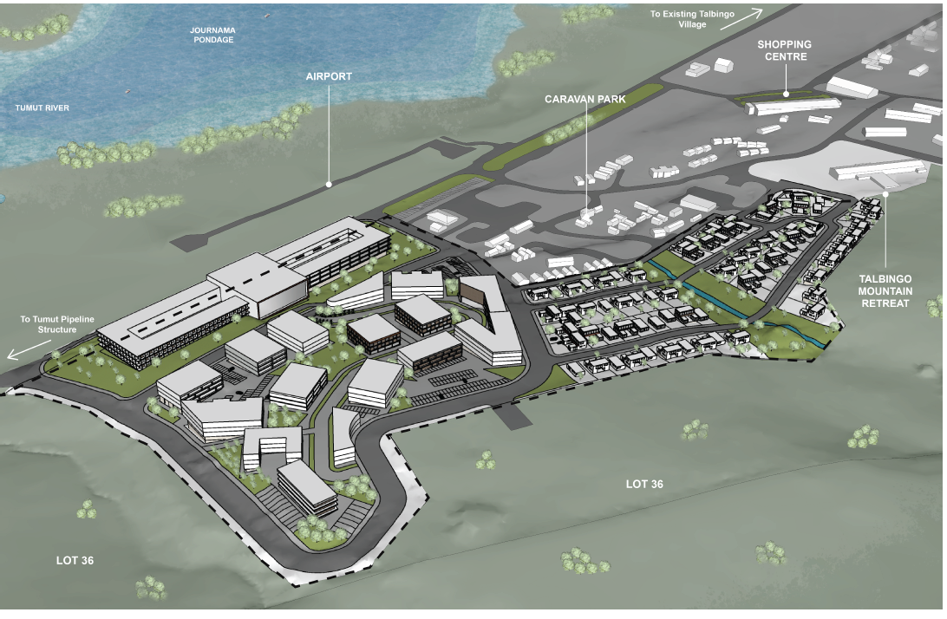
Figure 32: Massing of Concept Development (Source: West Talbingo Village Master Plan – Robert Harwood Architects)

The following additional information was requested from the applicant to demonstrate the suitability of the proposal:

- Urban Design Study / Analysis
- Servicing Report
- Solar Access Assessment
- Traffic and Parking Assessment
- Safer by Design Report
- Social Impact Assessment
- Needs Analysis
- Views and Visual Impact Assessment

The above information was not submitted by the applicant and therefore insufficient information has been submitted with the application to demonstrate the suitability of the site for the form, scale and density of the development proposed as well as the need for and compatibility of the development proposed.

As the development application seeks concept approval for the future uses, built form, scale and density outlined in the documentation submitted, the impacts of the conceptual built form, scale and density have been considered in the assessment.

The form, scale and density of the proposed concept development is not considered to be compatible with the existing and future desired character of Talbingo and will result in adverse built environment and social impacts on the locality and the site is therefore not considered suitable for the development (Section 4.15(1)(b) and (c)).

The proposed development is considered to be inconsistent with the objective of the RU5 Rural Village zone as it proposes a significant intensification of development within Talbingo that will provide development of a bulk, scale and charter that is inconsistent with the existing rural village character of the area.

Whilst the development will provide for a range of land uses, services and facilities the bulk, scale, density and character of development is incompatible with the existing and desired future character of the rural village.

Insufficient information has been submitted to demonstrate that the proposed development can be provided with the relevant essential services without resulting in adverse impacts on existing infrastructure or the surrounding area.

Furthermore, no Traffic Impact Assessment was submitted in support of the application to justify the development in terms of access, provision of car parking or impact on the local road network.

Given the adverse built form impacts and inconsistencies and non-compliances with the key objectives and controls of the Tumut LEP 2012 and Snowy Valleys DCP It is considered that a concept development application is the incorrect pathway to achieve the desired outcome for the site by the applicant.

If the proposal is to be pursued by the applicant, the proper process for consideration of the proposal would be a planning proposal that seeks to amend the Tumut Local Environmental Plan 2012 to provide suitable planning controls and a site-specific development control plan to facilitate future development.

Natural Environment Impacts

The proposed development is considered to result in adverse impacts on the natural environment as follows:

- Insufficient information has been submitted with the application to adequately demonstrate that the site is considered suitable for the intended use from a contamination perspective.
- Insufficient information has been submitted with the application to demonstrate that the proposed development will not impact on koalas or potential koala habitat.
- NSW RFS advised they cannot support the proposed development as the requested information was not received within the legislative timeframe to allow for assessment of the application.
- Insufficient information has been submitted in support of the application to determine the flood affectation of the site and the development’s consistency with the flood affectation of the site.
- Insufficient information was submitted with the application to demonstrate that future landscaping would enhance the visual character of the development and complement the design/use of spaces within and adjacent to the site.
- Insufficient information has been submitted to demonstrate how stormwater for future development is to be managed and integrated within the existing system.

Social and Economic Impacts

The proposed development is considered to result in adverse social and economic impacts on the surrounding as the development in its current form will result in a built form that is inconsistent with the existing and desired future character of the area and the objectives of the RU5 Rural Village zone.

Insufficient information has been submitted to demonstrate that the proposed development will not result in adverse impacts on existing infrastructure within the area.

Furthermore, the application was lodged with an estimated cost of works of $35 million however no Quantity Surveyors Report was submitted with the application. On 25 August 2022 Council requested a formal Quantity Surveyors Report be provided to confirm the Capital Investment Value of the project.

A Capital Investment Value (CIV) Report was submitted by the applicant in October 2022 (Attachment 9) which detailed the total development cost as being $427,465,743.00. The relevant Development Application fees were calculated and paid based on the $35 million value and the applicant has refused to pay the additional application fees for the updated cost of development.

(1)(c) The suitability of the site

The site is not considered to be suitable for the proposed development in its current form for the following reasons:

- The proposed development will result in a built form that is inconsistent with the existing and desired future character of the area.
- The proposed development is inconsistent with the objective of the RU5 Rural Village zone.
- Insufficient information has been submitted with the application to adequately demonstrate that the site is considered suitable for the intended use from a contamination perspective.
- Insufficient information has been submitted with the application to demonstrate that the proposed development will not impact on koalas or potential koala habitat.
- NSW RFS advised they cannot support the proposed development as the requested information was not received within the legislative timeframe to allow for assessment of the application.
- Insufficient information has been submitted in support of the application to determine the flood affectation of the site and the development’s consistency with the flood affectation of the site.
- Insufficient information was submitted with the application to demonstrate that future landscaping would enhance the visual character of the development and complement the design/use of spaces within and adjacent to the site.
- Insufficient information has been submitted to demonstrate how stormwater for future development is to be managed and integrated with existing infrastructure within the surrounding area.
- Insufficient information has been submitted to demonstrate that the proposed development will not adversely impact on the surrounding road network from a traffic generation and parking perspective.

The site is therefore not considered to be suitable for the development.

(1)(d) Any submissions made in accordance with this Act or the Regulations.

The Development Application was advertised for a period of 28 days 1 December 2021 and 10 January 2022. 44 submissions were received during the notification period of which 7 where in support and 37 objected to the application.

The 7 submissions in support of the application raised the following comments:

- Provides infrastructure that supports increase tourism.
- Positive outcomes for existing business and new business.
- Positive outcomes for the region.
- Supports in attracting new people in the town.
- Supports in providing viability to the town.
- Provides for a future for next generations.
- Local and regional benefits as a result of increased population and tourism.

A review of the submission received objecting to the development has also been undertaken and a response to each key issue raised is provided below.
Objection | Response
Services impacts including water supply, sewage, stormwater, telecommunication electricity and the like. | Insufficient information has been submitted in support of the application to demonstrate how essential services are to be provided to facilitate the future development of the site. Council requested a Servicing Report to demonstrate how essential services are to be provided to facilitate the future development of the site. A Servicing Report was not submitted by the applicant.
Built form Impacts | The proposed development is inconsistent with the existing and desired future character of the surrounding rural village area. The development does not appropriately recognise the desirable elements of the location’s current character or contribute to the quality and identity of the area by providing a built form, scale and density that is compatible with existing development in the area or the RU5 zoning of the site and surrounding area.  Talbingo is a small village with a population of around 239 residents characterised by a predominantly single storey-built form character and is subject to a maximum building height control of 7.2m under the Snowy Valleys DCP. The proposed development seeks concept approval for a tourist and visitor accommodation, residential flat buildings, shop top housing, terrace housing and dwelling houses with a height of 2-4 storeys. The concept approval would result in a significant increase in the density, bulk and scale of development within the locality.
Landscape Impacts | Insufficient information was submitted with the application to demonstrate that future landscaping would enhance the visual character of the development and complement the design/use of spaces within and adjacent to the site.
Overcrowding and over development Impacts | The proposed development seeks concept approval for a tourist and visitor accommodation, residential flat buildings, shop top housing, terrace housing and dwelling houses with a height of 2-4 storeys. The concept approval would result in a significant increase in the density, bulk and scale of development within the locality.  The following additional information was requested from the applicant to demonstrate the suitability of the proposal:  • Urban Design Study / Analysis  • Servicing Report  • Solar Access Assessment  • Traffic and Parking Assessment  • Safer by Design Report  • Social Impact Assessment  • Needs Analysis  • Views and Visual Impact Assessment  The above information was not submitted by the applicant and therefore insufficient information has been submitted with the application to demonstrate the suitability of the site for the form, scale and density of the development proposed as well as the need for and compatibility of the development proposed.
Flora and Fauna impacts and Biodiversity Impacts | The Flora and Fauna Assessment submitted in support of the application was prepared in 2006 and does not include a sufficient assessment of the existing conditions of the site or potential impacts of the development.  An updated assessment was requested from the applicant which was not submitted.  Therefore, insufficient information was submitted in support of the application to demonstrate the development would not have any adverse impacts on flora and fauna or biodiversity within the area.
Traffic Impacts | No Traffic Impact Assessment was submitted in support of the application to justify the development in terms of access, provision of car parking or impact on the local road network. Therefore, insufficient information has been submitted in support of the development to address traffic impacts.
Heritage Impacts | The Aboriginal Heritage Report submitted in support of the application was prepared in 2006. An updated report was requested from the applicant to ensure it appropriately addressed the existing conditions of the site and the relevant legislation / guidelines. An updated report was not submitted by the applicant. Therefore, insufficient information has been submitted in support of the development to address potential heritage impacts.
Visual impacts | A Visual Impact Assessment was requested from the applicant and was not provided. Therefore, insufficient information has been submitted in support of the development to address potential visual impacts.
Noise impacts | Potential noise impacts will be addressed under future detailed development applications.
Social Impacts | The proposed development is considered to result in adverse social and economic impacts on the surrounding as the development in its current form will result in a built form that is inconsistent with the existing and desired future character of the area and the objectives of the RU5 Rural Village zone.  Insufficient information has been submitted to demonstrate that the proposed development will not result in adverse impacts on existing infrastructure within the area.
lack of consultation | The application was publicly notified in accordance with the requirements of the Environmental Planning and Assessment Regulations 2000 from the 1 December 2021 to the 10 January 2022.
Amenity impacts | Insufficient information was submitted with the application to demonstrate that adequate amenity would be provided for future residents.
Block size compliance | The indicative subdivision layout complies with the minimum lot size requirements of the Tumut LEP 2012.
Character | The proposed development is inconsistent with the existing and desired future character of the surrounding rural village area. The development does not appropriately recognise the desirable elements of the location’s current character or contribute to the quality and identity of the area by providing a built form, scale and density that is compatible with existing development in the area or the RU5 zoning of the site and surrounding area.  The form, scale and density of the proposed concept development is not considered to be compatible with the existing and future desired character of Talbingo and will result in adverse built environment and social impacts on the locality and the site.
Staging of the development | The proposed development is accompanied by Staging Plans that detail the staging of the development and an indicative timeframe for the relevant stages was provided in the Statement of Environmental Effects.
Bushfire Impacts | On 20 May 2022 NSW RFS requested additional information noting that the Bushfire Report submitted in support of the application was prepared in 2006. An updated Bushfire Report was requested to be provided within 100 days.  On 12 September 2022 NSW RFS advised they cannot support the proposed development as the requested information was not received within the legislative timeframe to allow for assessment of the application.

(1)(e) The public Interest

The public interest is served through the detailed assessment of this DA under the Environmental Planning and Assessment Act 1979, the Environmental Planning and Assessment Regulation 2000, Environmental Planning Instruments, Development Control Plan and policies.

That assessment has demonstrated that the proposed development is not in the public interest.

OTHER MATTERS

External Referrals

The subject application is classed as Integrated Development under Clause 4.46 of the Environmental Planning and Assessment Act 1979 (EP&A Act) as follows:

- Natural Resource Access Regulator (NRAR) - A controlled activity at a specified location in, on or under waterfront land (within 40m) (Water Management Act 2000).
- Rural Fire Service (RFS) - Subdivision of Bushfire Prone land for residential purposes (Rural Fires Act 1997)
- NSW Office of Environment & Heritage - The land may contain items which are of archaeological or heritage significance (National Parks & Wildlife Act 1974).

On 20 May 2022 NSW RFS requested additional information noting that the Bushfire Report submitted in support of the application was prepared in 2006. An updated Bushfire Report was requested to be provided within 100 days.

On 12 September 2022 NSW RFS advised they cannot support the proposed development as the requested information was not received within the legislative timeframe to allow for assessment of the application.

Due to Council’s issues with the application and the deficiencies with the documentation submitted in support of the application the DA was not referred to NRAR or the NSW Office of Environment & Heritage. The applicant did not provide additional information within the timeframe provided by Council and therefore no referrals were made to the relevant agencies.

Consistency with LSPS

Whilst there is no statutory requirement to undertake an assessment against the LSPS it has been considered in this assessment given the inconsistencies and non-compliances with the relevant objectives and controls of the Tumut LEP 2012 and Snowy Valleys DCP 2019 proposed under the subject application.

The LSPS provides the following overview of Talbingo:

Visitors regularly inflate the town to several times its resident population. The number and diversity of visitors confirms Talbingo to be a preferred location for reunions, group outings and activities, weddings, and away-from-it-all peace and quiet.

Surrounded by National Park and State Native Forest, Talbingo is the popular base for communing with nature or adventuring in the vastness of Kosciuszko National Park and its adjacent Forests, or exploring one of the many roads, tracks or trails. Visitors to Talbingo can choose to stay in town and enjoy a magic atmosphere in the company of the resident wild kangaroo population, up to 100 or so species of Australian birds, the human locals and other visitors.

A street grid pattern slightly curved to follow contours is exhibited within the existing developed portion on the eastern half of Talbingo. This pattern is altered on the western part that is predominantly undeveloped. Zoning of these lands is RU5 Village. Applicable minimum lot size for the RU5 zone is 225m².

R5 Large Lot Residential zones adjoin the Village zone on the southern and eastern boundaries. Minimum lot sizes applicable in the R5 zones are a combination of 2 hectares and 5,000m². Development can be accommodated without escalating the RU5 Village and R5 Large Lot Residential zones footprints.

The Structure Plan for Talbingo is provided in Figure 33 below:

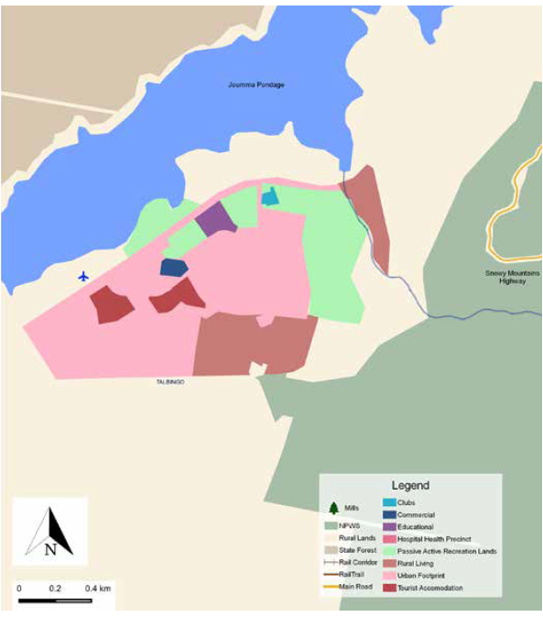
Figure 33: Talbingo Structure Plan (Source: Snowy Valleys LSPS)
The site is mapped for urban development and tourist accommodation. The LSPS details that development can be accommodated within Talbingo without escalating the existing development controls.

The site provides the opportunity for future residential, commercial, and tourist and visitor development based on the structure plan and applicable RU5 Rural Village Zoning however this needs to be undertaken in a form that is compatible with the existing and desired future character of the rural village context.

The proposed development is considered inconsistent with the existing and desired future character of the surrounding rural village area. The development does not appropriately recognise the desirable elements of the location’s current character or contribute to the quality and identity of the area by providing a built form, scale and density that is compatible with existing development in the area or the RU5 zoning of the site and surrounding area.

Talbingo is a small village with a population of around 239 residents characterised by a predominantly single storey-built form character and is subject to a maximum building height control of 7.2m under the Snowy Valleys DCP. The proposed development seeks concept approval for a tourist and visitor accommodation, residential flat buildings, shop top housing, terrace housing and dwelling houses with a height of 2-4 storeys. The concept approval would result in a significant increase in the density, bulk and scale of development within the locality.

CONCLUSION

Council is receipt of a Concept Development Application consisting of a Spa Hotel (tourist a visitor accommodation), 80 residential lots for detached dwellings, residential flat buildings, shop top housing, multi dwelling housing (terraces) development, subdivision and associated site works at Lot 35 DP878862, Miles Franklin Drive, Talbingo.
The proposed development is considered unsatisfactory with respect to the relevant provisions of:

- Tumut Local Environmental Plan 2012
- Snowy Valleys Development Control Plan 2019.

The proposed development is also considered likely to have various significant negative environmental and social impacts in the locality, and the land is considered unsuitable for the proposed development. Advertisement and notification attracted significant objection with valid grounds, and there is not considered to be any overriding public interest in favour of the proposed development.

Furthermore, there are jurisdictional issues that have not been appropriately addressed restricting the ability to approve the development which are as follows:

- Insufficient information has been submitted with the application to adequately demonstrate that the site is considered suitable for the intended use as required under Clause 4.6 of SEPP (Resilience and Hazards) 2021;
- Insufficient information has been submitted to demonstrate compliance with Clause 6.11 of the Tumut LEP 2012 relating to arrangements for essential services for the development.
- The various external agencies have not provided their general terms of approval.

Given the above, the proposed development is considered unsatisfactory with respect to the matters for consideration specified by section 4.15 (1) (a) (i) & (iii), (b), (c), (d) and (e) of the Environmental Planning and Assessment Act 1979.

RECOMMENDATION

That the Panel determine DA2021/0257 consisting of a Concept Development Application consisting of a Spa Hotel (tourist a visitor accommodation), 80 residential lots for detached dwellings, residential flat buildings, shop top housing, multi dwelling housing (terraces) development, subdivision and associated site works at Lot 35 DP878862 Miles Franklin Drive, Talbingo by way of refusal pursuant to Section 4.16 of the Environmental Planning and Assessment Act 1979 in line with the recommended reasons for refusal outlined in Attachment 14 to this report.

